

Requirement & Design Specification

**Tech Store Management System (TSMS)**

**Version: 1.0**

– Hanoi, June 2025 –

# Record of Changes

| **Version** | **Date** | **A* M, D** | **In charge** | **Change Description** |
| --- | --- | --- | --- | --- |
| V1.0 | 1/7 | A | PhuongNDP | Add context diagrams |
| V1.0 | 2/7 | M | NamTQ | Brachs Manager Screens Flows |
| V1.0 | 3/7 | A | PhuongNDP | Add ERD diagram and table descriptions |
| V1.0 | 3/7 | A | NamTQ | Shop owner Screens Flows |
| V1.0 | 5/7 | M | PhuongNDP | Fix ERD diagram and table descriptions |
| V1.0 | 11/7 | A | NamTQ | Add Screen flow |
| V1.0 | 14/7 | A | PhuongNDP | Add contents map |
| V1.0 | 14/7 | M | NamTQ | Update UC diagrams and function specification |
| V1.0 | 17/7 | M | PhuongNDP | Update UC diagrams and function specification |
| V1.0 | 19/7 | A | PhuongNDP | Add new function specifications |
| V1.0 | 20/7 | A | PhuongNDP | Add new function specifications |
| V1.0 | 21/7 | A | NamTQ | Add limitations, exclusions, and business rules |
| V1.0 | 23/7 | M | NamTQ | Add new function specifications |
|  |  |  |  |  |
|  |  |  |  |  |
|  |  |  |  |  |
|  |  |  |  |  |
|  |  |  |  |  |
|  |  |  |  |  |

*A - Added M - Modified D - Deleted

Contents

Record of Changes 2

I. Overview 4

1. System Context 5

2. User Requirements 6

2.1 Actors 6

2.2 Diagrams 7

2.3 Descriptions 11

3. System Functionalities 13

3.1 Screens Flow 13

3.2 Screen Authorization 16

3.3 Non-UI Functions 17

II. Functional Requirements 18

1. Login&Register 18

1.1. System Access 18

1.2. Register 21

2. Profile Dashboard 22

2.1. View&Update Profile 22

2.2. Other Functions 24

3. Shop/Branch Overview 32

4. Product Management 33

4.1. View Product List 33

4.2. View Product Details 35

4.3. Add Product 36

5. Order Management 37

5.1. View Order List 37

5.2. View Order Details 39

6. Partner Management 41

6.1. View Customer List 41

6.2. Update Customer Details 42

6.3. View Supplier List 43

7. Staff Management 44

7.1. View Staff List 44

7.2. Update Staff Details 45

7.3. Add A New Staff 46

7.4. View Shift List 48

7.5. Update Shift Details 49

7.6. Create A New Shift 50

8. Promotion Management 51

8.1. View Promotion List 51

8.2. Update Promotion Details 53

8.3. Create A New Promotion 53

9. Shop/Branch Report 54

9.1. Revenue Report 54

9.2. Expense Report 55

10. Sell-In-Store 58

10.1. Process Of Creating An Order 58

10.2. Create A New Customer 59

11. Import/ Export Management 61

11.1. Tracking Import orders 61

11.2. Tracking Export Order 63

11.3. Tracking Import request 65

11.4. Tracking Import Process 67

11.5. Tracking Export/Import Of Warehouse 69

11.6. Create Order Export 72

III. System Design 74

1. Database Design 74

1.1 Database Schema 75

[1.2 Table Descriptions](https://docs.google.com/document/d/1yLuDev4tPc27eii0Elhga5c15vmzagmaTx9PWlJeNeA/edit#heading=h.cpi9tujlzpol) 77

2. Code Packages 79

2.1 Package Diagram 11

2.2 Package Descriptions 11

IV. Appendix 19

1. Assumptions & Dependencies 19

2. Limitations & Exclusions 19

3. Business Rules 19

# I. Overview

## 1. System Context

The Tech Store Management System is a centralized web-based platform designed to support the operations of a tech retail chain, including shop management, inventory tracking, order processing, staff coordination, and warehouse logistics. It serves multiple roles such as Shop Owners, Branch Managers, Sale Staffs, Warehouse Managers, and Super Admins, enabling them to perform role-specific tasks efficiently. The system also integrates with external services like VietQR for payment processing and Mail Service for notifications. The system will be used by internal roles such as Shop owner, Branch manager, Sale staff, Warehouse Manager; as well as a System Admin who manages Shop owner accounts.

Context diagram: [TSMS Context Diagram](https://app.diagrams.net/?splash=0#G1q2Dc0f1ZQ9gf59k0JdYgVag8IeUw7xvb#%7B%22pageId%22%3A%22Jpgdxu5JG6J-21FNDAyR%22%7D)

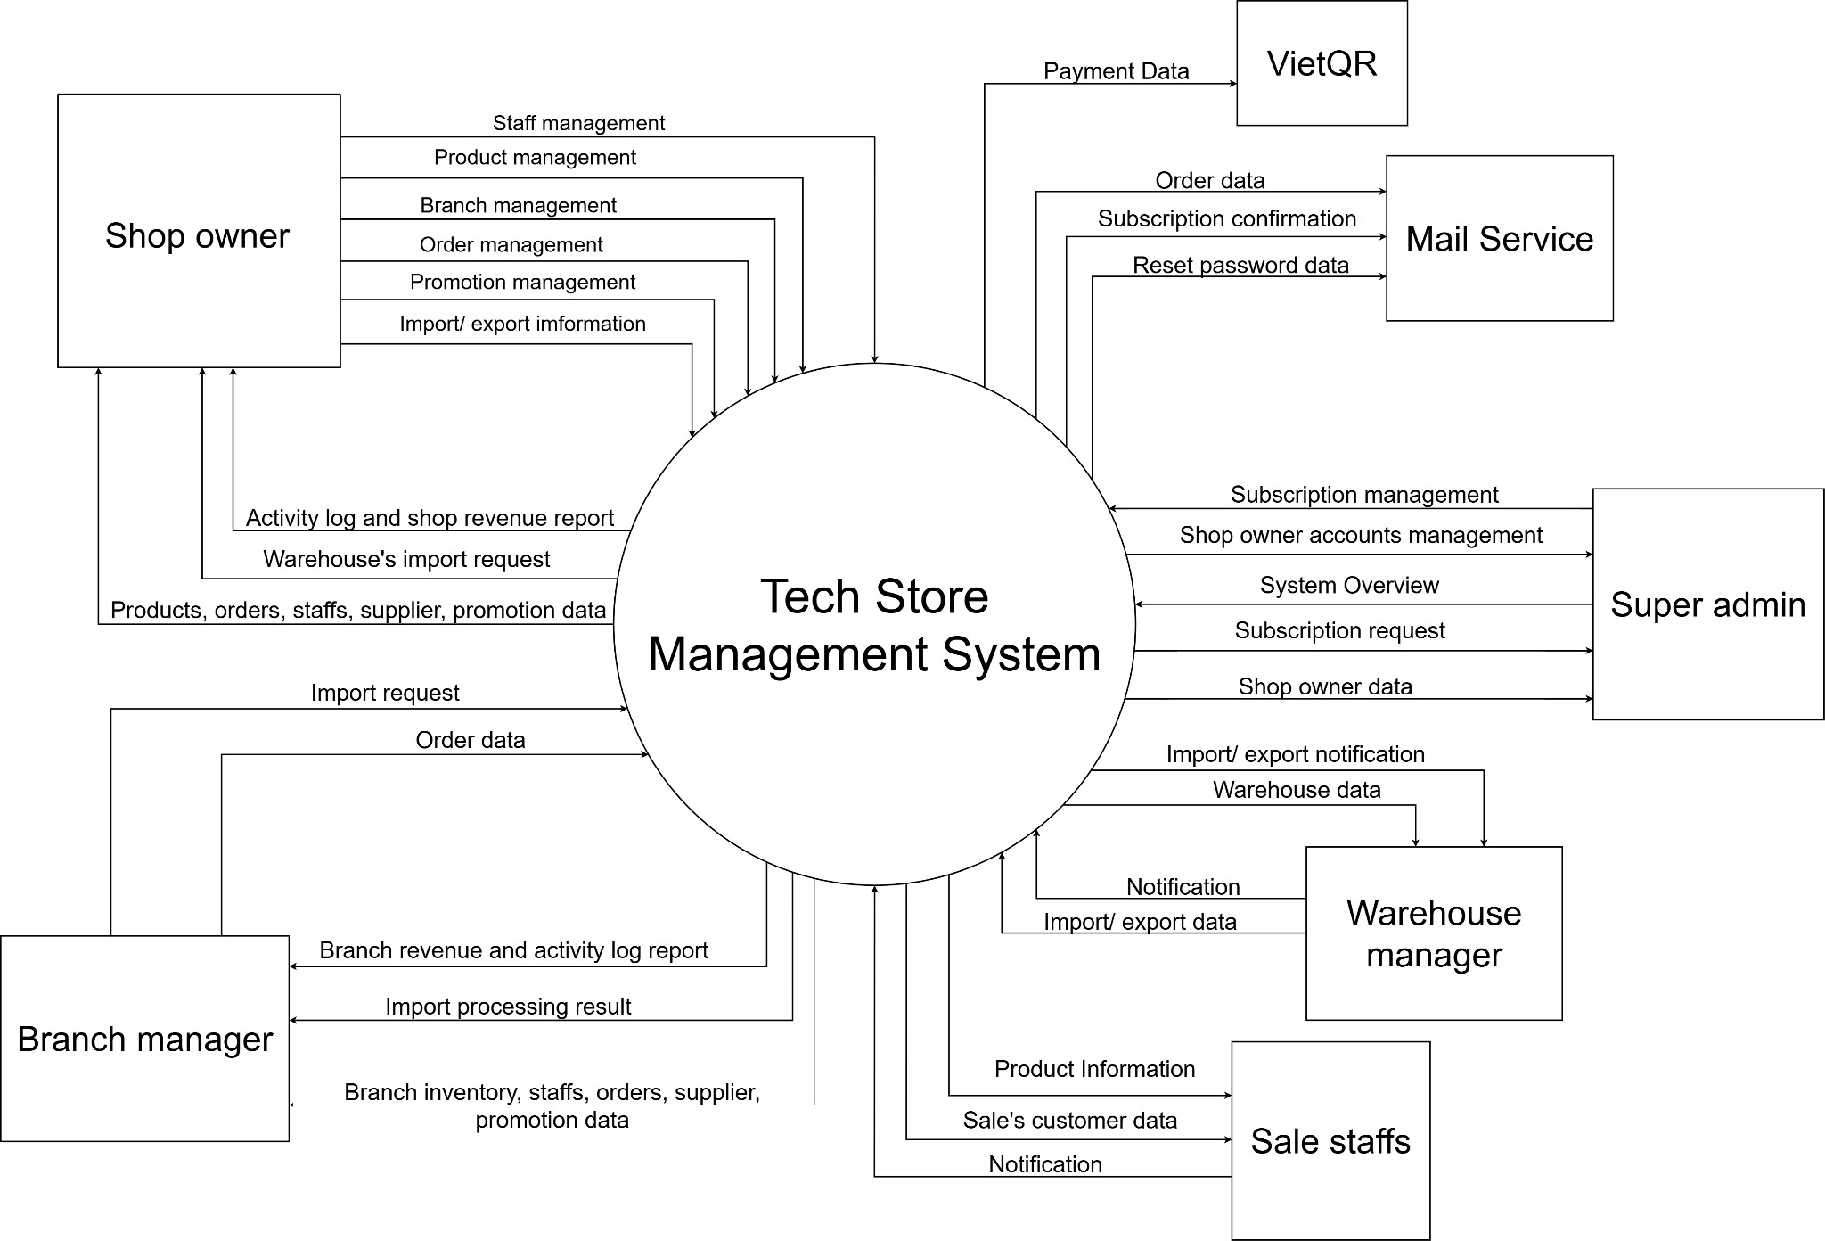

## 2. User Requirements

### 2.1 Actors

| **#** | **Actor** | **Description** |
| --- | --- | --- |
| 1 | Shop-owner | ***Owner of the entire chain of stores.***  **Permissions:**  - Access and manage all data in the system.  - Create/edit/delete branches, warehouses, user accounts.  - Track revenue reports, cash flow, inventory at all branches and warehouses.  - Set up promotions across the system. |
| 2 | Branch-Manager | ***Responsible for managing operations at a specific branch.***  **Permissions**:  - Manage sales staff at the branch. - Create orders and handle customer-related activities.  - Monitor inventory at the branch and request stock from the warehouse. - View local promotions and internal announcements. |
| 3 | Sale Staff | ***Frontline staff responsible for selling products and assisting customers.***  **Permissions**:  - View sales orders, view promotions.  - Look up product information, inventory at the branch.  - View customer information.  - No access to system-wide data or other branches. |
| 4 | Warehouse Staff | ***In charge of managing warehouse operations.***  **Permissions**:  - Track and update product quantities in the warehouse.  - Handle stock transfers between the warehouse and branches  - Conduct inventory checks and submit warehouse reports.  - No access to sales or customer-related data. |

### 

### 

### 

### 

### 

### 

### 

### 

### 

### 2.2 Diagrams

#### 2.2.1 UCs for Shop Owner

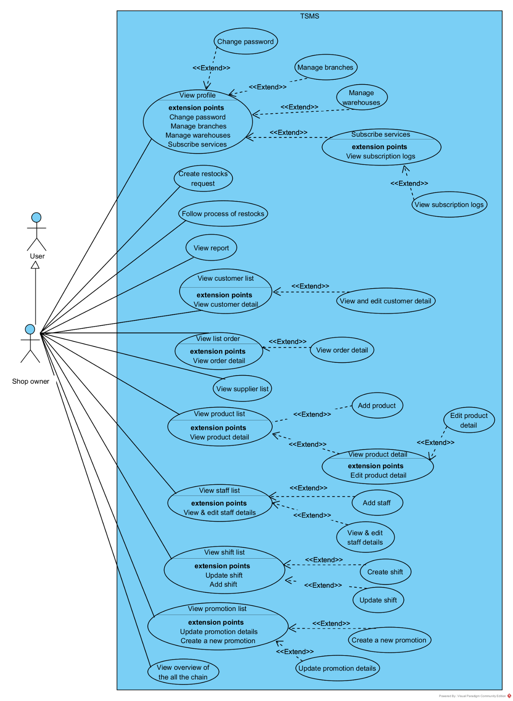

#### 2.2.2 UCs for Branch Manager

#### 

#### 2.2.3 UCs for Sale

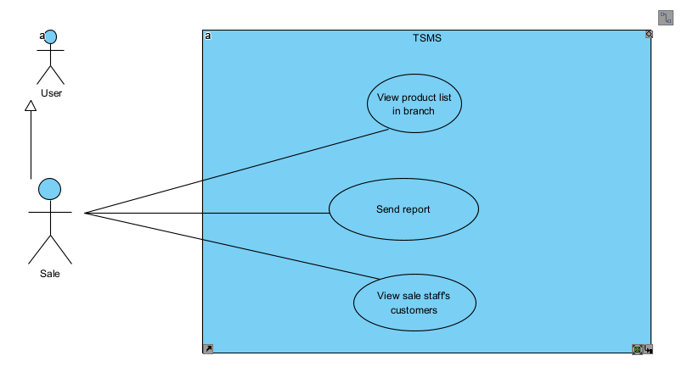

#### 2.2.4 UCs for Super Admin

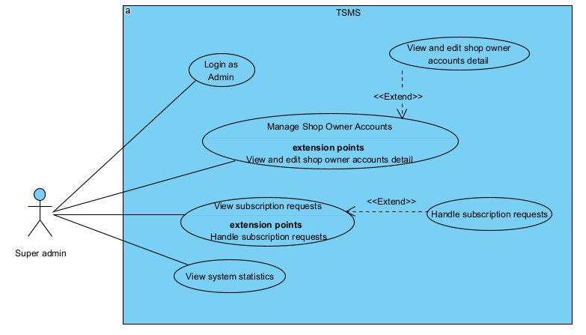

#### 2.2.5 UCs for Warehouse Manager

#### 

#### 2.2.6 UCs for User

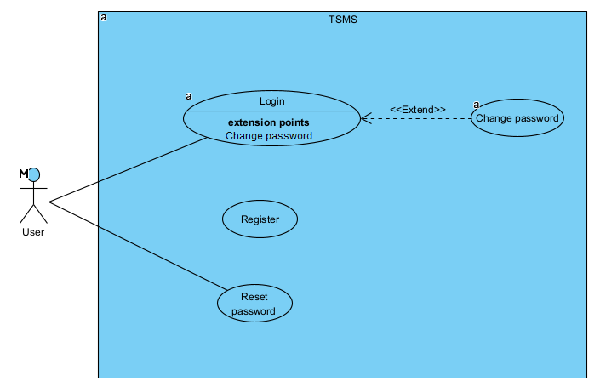

### 2.3 Descriptions

| **ID** | **Use Case** | **Actor(s)** | **Use Case Description** |
| --- | --- | --- | --- |
| 01 | Login system | Shop Owner, Branch Manager, Sale, Warehouse Manager |  |
| 02 | Reset password | Shop Owner, Branch Manager, Sale, Warehouse Manager |  |
| 03 | Register | Customer |  |
| 04 | View&Update profile | Shop Owner, Branch Manager, Sale, Warehouse Manager |  |
| 05 | Change password | Shop Owner, Branch Manager, Sale, Warehouse Manager |  |
| 06 | Manage Branch | Shop Owner |  |
| 07 | Manage Warehouse | Shop Owner |  |
| 08 | Subscribe services | Shop Owner |  |
| 09 | View subscription logs | Shop Owner |  |
| 10 | View overview | Shop Owner, Branch Manager |  |
| 11 | View products list | Shop Owner, Branch Manager, Sale, Warehouse Manager |  |
| 12 | Update product | Shop Owner |  |
| 13 | Add product | Shop Owner |  |
| 14 | View order list | Shop Owner, Branch Manager |  |
| 15 | View order detail | Shop Owner, Branch Manager, |  |
| 16 | View customer list | Shop Owner, Branch Manager, Sale |  |
| 17 | View and edit customer detail | Shop Owner, Branch Manager |  |
| 18 | View supplier list | Shop Owner, Branch Manager |  |
| 19 | View staff list | Shop Owner, Branch Manager |  |
| 20 | View & edit staff details | Shop Owner |  |
| 21 | Add staff | Shop Owner |  |
| 22 | View shift list | Shop Owner |  |
| 23 | Update shift | Shop Owner |  |
| 24 | Create a new shift | Shop Owner |  |
| 25 | View promotion list | Shop Owner, Branch Manager |  |
| 26 | Update promotion details | Shop Owner |  |
| 27 | Create a new promotion | Shop Owner |  |
| 28 | View report | Shop Owner, Branch Manager |  |
| 29 | Create a new order | Branch Manager |  |
| 30 | Add a new customer | Branch Manager |  |

## 3. System Functionalities

### 3.1 Screens Flow

#### 3.3.1. Screens Flow of Shop Owner

### 

### 

### 

### 

### 

### 

### 

### 

### 

### 

#### 3.3.2. Screens Flow of Branch Manager

### 

#### 3.3.3. Screens Flow of Warehouse Manager

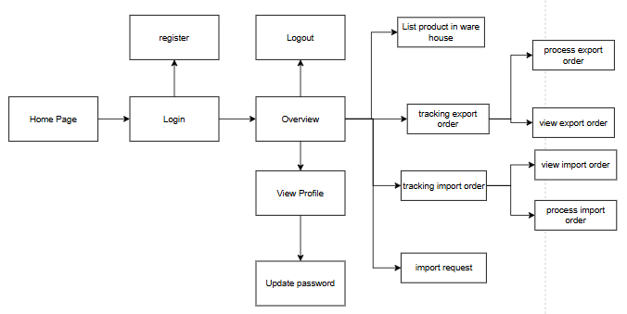

### 

### *3.3.4. Screens Flow of Sale Staff*

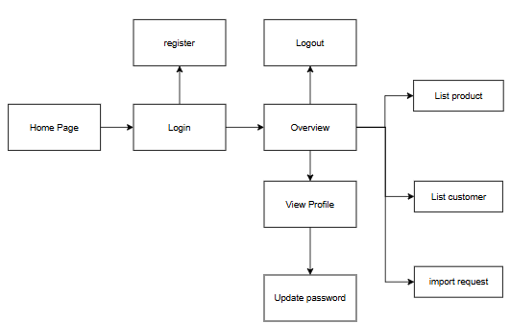

### *3.3.5. Screens Flow of Super Admin*

### 

### 

### 3.2 Screen Authorization

| **Screen** | **Shop-owner** | **Branch Manager** | **Sale Staffs** | **Super Admin** | **Warehouse Manager** |
| --- | --- | --- | --- | --- | --- |
| Admin Login Page |  |  |  | x |  |
| SO Account Management |  |  |  | x |  |
| Subscription |  |  |  | x |  |
| View/ update shop owner detail |  |  |  | x |  |
| Home page | x | x | x |  | x |
| User Login | x | x | x |  | x |
| Register | x | x | x |  | x |
| Update password | x | x | x |  | x |
| Overview | x | x |  |  |  |
| View profile | x | x | x |  | x |
| Add product | x |  |  |  |  |
| Product | x | x | x |  | x |
| Product detail | x | x | x |  | x |
| Add new product | x |  |  |  |  |
| Create import order | x |  |  |  |  |
| Tracking order import | x |  |  |  | x |
| Detail order import | X |  |  |  | X |
| Tracking order export |  | x |  |  | x |
| Detail order export |  | x |  |  | x |
| Order list | x | x |  | x |  |
| List supplier | x | x |  |  |  |
| Add supplier | x |  |  |  |  |
| List Customer | x | x |  | x |  |
| Add Customer | x | x |  |  |  |
| Shift Management | x |  |  |  |  |
| Staff list | x | x |  |  |  |
| List Promotions | x | x |  |  |  |
| Add promotions | x |  |  |  |  |
| Promotions detail | x | x |  |  |  |
| Invoice report | x | X |  |  |  |
| Outcome report | x | x |  |  |  |
| Commission Record | x | x | x |  |  |
| Warehouse status manage | x |  |  |  |  |
| order list | x | x | x |  | x |
| Subscriber services | x |  |  |  |  |
| View subscribe services log | x |  |  |  |  |
| Sell in store |  | x |  |  |  |
| List product in warehouse |  |  |  |  | x |
| Process export/import order |  |  | x |  | x |

### 3.3 Non-UI Functions

| **#** | **Feature** | **System Function** | **Description** |
| --- | --- | --- | --- |
| 1 | Data Maintenance | User archive expired | Automatically lock or disable user accounts after 7-day trial expires |
| 2 | Logging & Audit | Audit Trail Recorder | Automatically record system logs: who created orders, edited products, applied promotions... for traceability and transparency. |
| 3 | Promotion Engine | Expired Promotion Cleaner | Automatically check and disable expired promotions to ensure no mistakes are made. |
| 4 | Product Serial Tracking | Serial Number Validator | Check for valid, unique serial numbers in the system when exporting, selling or transacting. |
| 5 | Product Update Consistency | Product Detail Versioning Tracker | Monitor any changes to product information to sync cache or check for unusual edits. |
| 6 | Stock Movement | Unresponded Transfer Cleaner | Automatically cancel unprocessed shipment requests after timeout (based on StockMovementsRequest). |
| 7 | Promotion Engine | Real-time Promotion Applier | During order creation, the backend checks for valid promotions and applies the promotional price if eligible. |
| 8 | Inventory | Auto Inventory Sync | Synchronize the quantity of goods between branches and the main warehouse after each import/export. |

# II. Functional Requirements

## 1. Login & Register

### 1.1 System Access

#### 1.1.1 User Login

This screen allows users to be authenticated to the system screens/functionalities.

Related use cases:

* UC01_Login System

##### UI Design

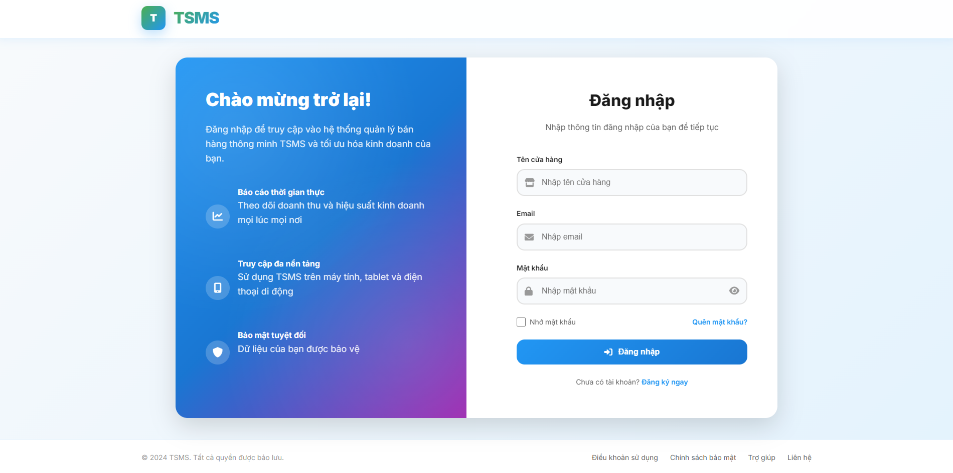

| **Field Name** | **Field Type** | **Description** |
| --- | --- | --- |
| Email* | Text Box | This is for user to input valid email address for logging in |
| Password* | Password Box | This is for user to input password for logging in |
| Login | Button | User clicks to authenticate him/herself into the system with provided email & password |
| Register | Button | User clicks to redirect to the User Register page for registering new user account to access the system |
| Forgot Password? | Hyperlink | User clicks to redirect to the Password Reset page for resetting his/her forgot password |
| Remember Password | Checkbox | This is for remember user id in cookie for the next login |

##### Database Access

| **Table** | **CRUD** | **Description** |
| --- | --- | --- |
| Users | R | Verify UserName & Password information |

#### 1.1.2 Reset password

This screen allows users to reset their password in case of forgetting it.

Related use cases:

* UC02 Reset Password

##### UI Design

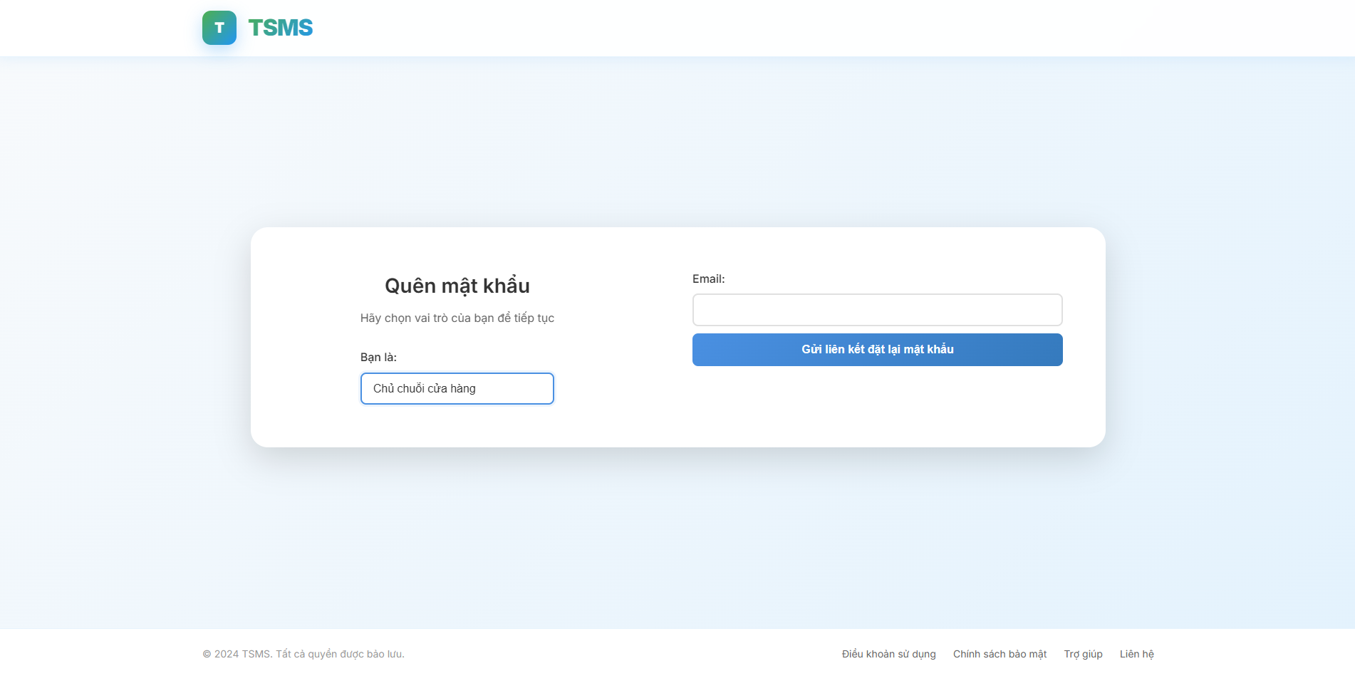

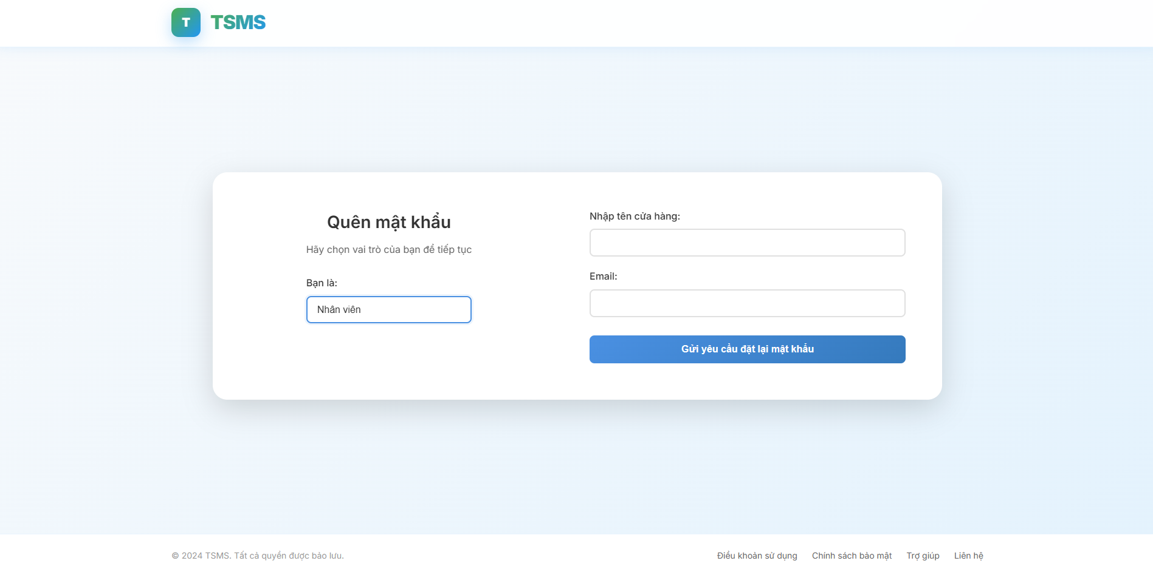

| **Field Name** | **Field Type** | **Description** |
| --- | --- | --- |
| Role Select | Dropdown | Allows the user to select their role (e.g., "Chủ chuỗi cửa hàng" - Shop owner) which influence the password reset process or email template. |
| ***Shop Owner Case*** | | |
| Email | Email Input | Used to enter the email address associated with the account to receive a password reset link. |
| Gửi liên kết đặt lại mật khẩu | Button | Initiates the process to send a password reset link to the provided email address. |
| ***Staff Case*** | | |
| Nhập tên cửa hàng | Text input | Used to enter the shop name associated with the account to receive a password reset link. |
| Email | Email Input | Used to enter the email address associated with the account to receive a password reset link. |
| Gửi liên kết đặt lại mật khẩu | Button | Initiates the process to send a password reset link to the provided email address. |

##### Database Access

| **Table** | **CRUD** | **Description** |
| --- | --- | --- |
| ShopOwners | U | Update shop owner password on the ShopOwners table |
| Users | U | Update users password on the ShopOwners table |
| PassowordResetToekns | R | Read operations on the PasswordResetTokens table. This suggests that the system retrieves password reset tokens, likely to validate them when a user attempts to reset their password. |

### 1.2 Register

This screen allows users to reset their password in case of forgetting it.

Related use cases:

* UC03 Resister User Account

##### UI Design

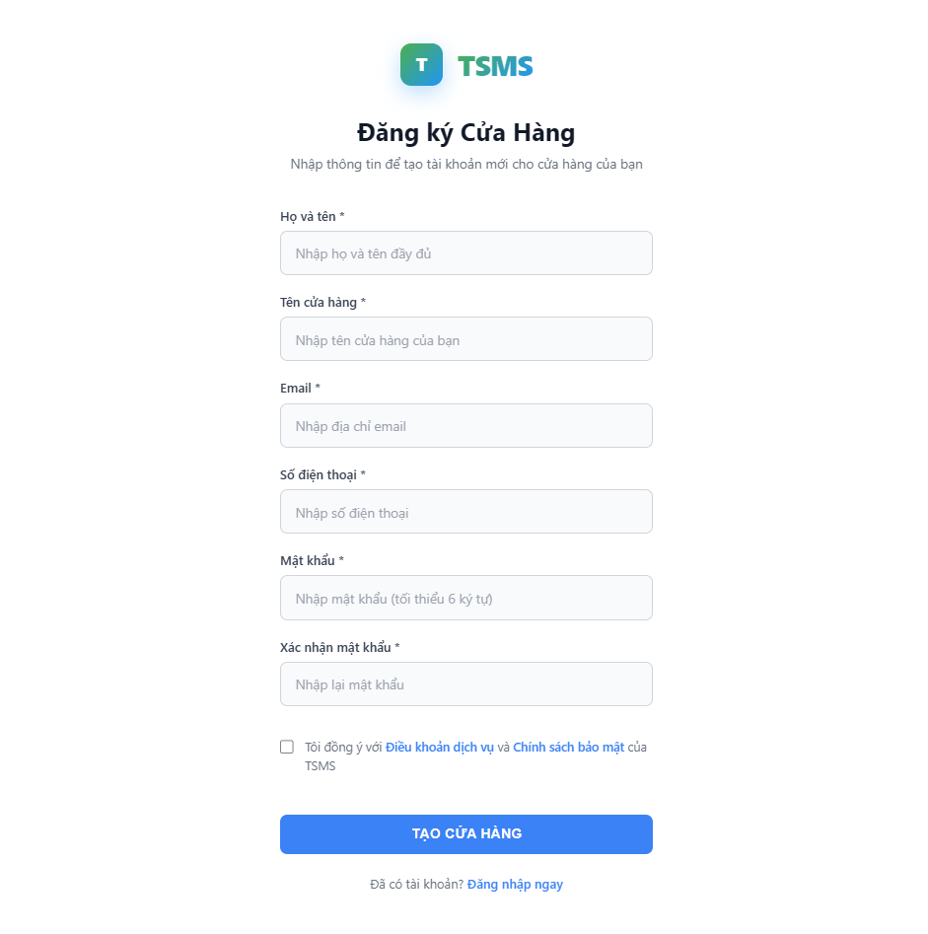

| **Field Name** | **Field Type** | **Description** |
| --- | --- | --- |
| Họ và tên* | Text Input | Used to enter the full name of the individual registering the store. (Placeholder: "Nhập họ và tên đầy đủ") |
| Tên cửa hàng* | Text Input | Used to enter the name of the store being registered. (Placeholder: "Nhập tên cửa hàng của bạn") |
| Email* | Email Input | Used to enter the email address for the store account. This will likely be used for login and communication. (Placeholder: "Nhập địa chỉ email") |
| Số điện thoại* | Number Input | Used to enter the contact phone number for the store. (Placeholder: "Nhập số điện thoại") |
| Mật khẩu* | Password Input | Used to set the password for the store account. It has a minimum length requirement (tối thiểu 6 ký tự - minimum 6 characters). (Placeholder: "Nhập mật khẩu (tối thiểu 6 ký tự)") |
| Xác nhận mật khẩu* | Password Input | Used to re-enter the password to confirm it matches the Mật khẩu field, preventing typos. (Placeholder: "Nhập lại mật khẩu") |
| Tôi đồng ý với Điều khoản dịch vụ và Chính sách bảo mật của TSMS | Checkbox | Requires the user to agree to the terms of service and privacy policy before creating the store. These are clickable links. |
| TẠO CỬA HÀNG | Button | Submits all the entered information to create the new store account |

##### Database Access

##### 

| **Table** | **CRUD** | **Description** |
| --- | --- | --- |
| ShopOwners | C | This indicates new shop owner records are being added to the database. |
| Users | C | This indicates new user (shop owner) records are being added to the database. |
| UserServiceMethod | C | Add service method for newly created shop owner account |

## 2. Profile Dashboard

### 2.1 View and update profile information

This screen allows users to view their profile.

Related use cases:

* 2.1 UC-4_View profile

##### UI Design

*Shop Owner Information

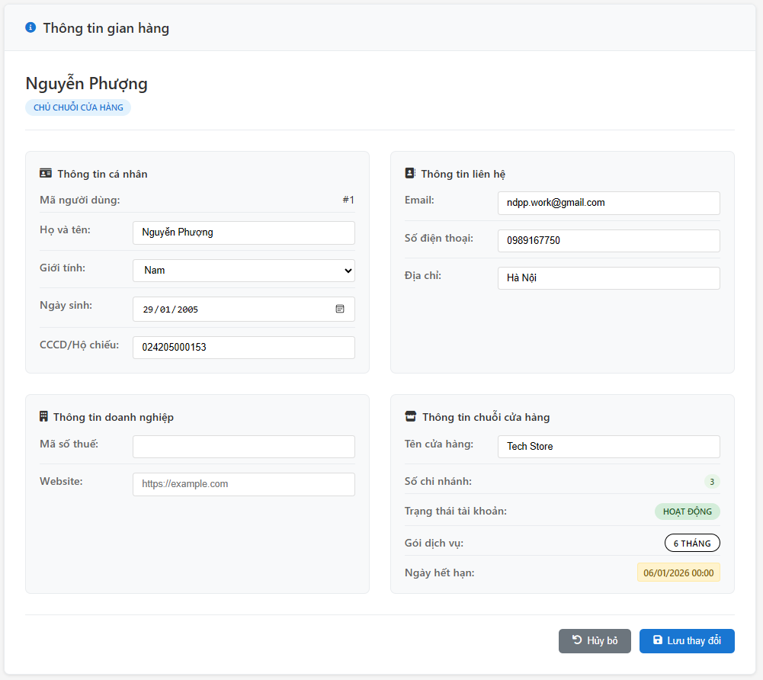

*Staff Information

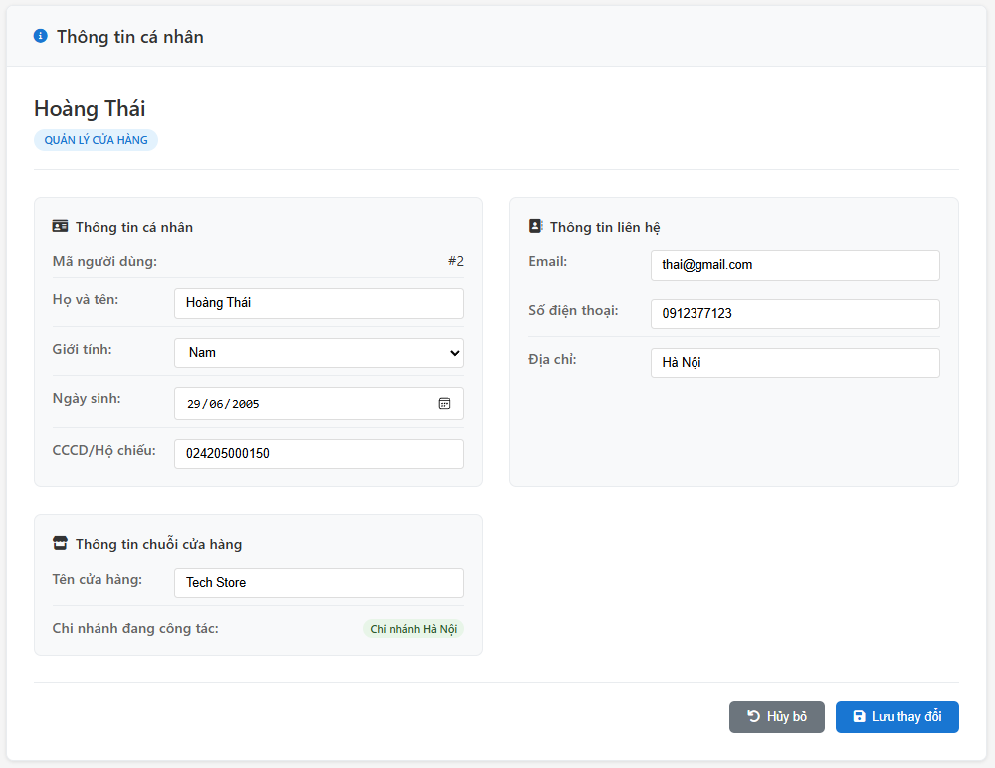

| **Field Name** | **Field Type** | **Description** |
| --- | --- | --- |
| Mã người dùng | Text (Read-only) | User ID. |
| Họ và tên | Text Input | Full name of the shop owner. |
| Giới tính | Dropdown | Gender of the shop owner. |
| Ngày sinh | Date Picker | Date of birth of the shop owner. |
| CCCD/Hộ chiếu | Text Input | ID card/Passport number of the shop owner. |
| Email | Text Input | Email address for contact. |
| Số điện thoại | Text Input | Phone number for contact. |
| Địa chỉ | Text Input | Address for contact. |
| Mã số thuế | Text Input | Tax ID number of the business. |
| Website | Text Input | Website URL of the business. |
| Tên cửa hàng | Text Input | Name of the shop. |
| Số chi nhánh | Text (Read-only) | Number of branches associated with the shop. |
| Trạng thái tài khoản | Text (Status) | Status of the account (e.g., HOẠT ĐỘNG - ACTIVE). |
| Gói dịch vụ | Text (Status) | Current service package of the shop (e.g., 6 THÁNG - 6 MONTHS). |
| Ngày hết hạn | Text (Date) | Expiry date of the current service package (e.g., 06/01/2026 00:00). |

##### Database Access

##### 

| **Table** | **CRUD** | **Description** |
| --- | --- | --- |
| ShopOwners | R/U | View and update information about shop owners. |
| Users | R/U | View and update general user information ( broader than ShopOwners). |
| UserServiceMethod | R | Read information about shop owner service packages/subscription methods in real time. |

### 2.2 Other functions

#### 2.2.1 Change password

This screen allows users to change their password.

Related use cases:

* UC-5_Change password

##### UI Design

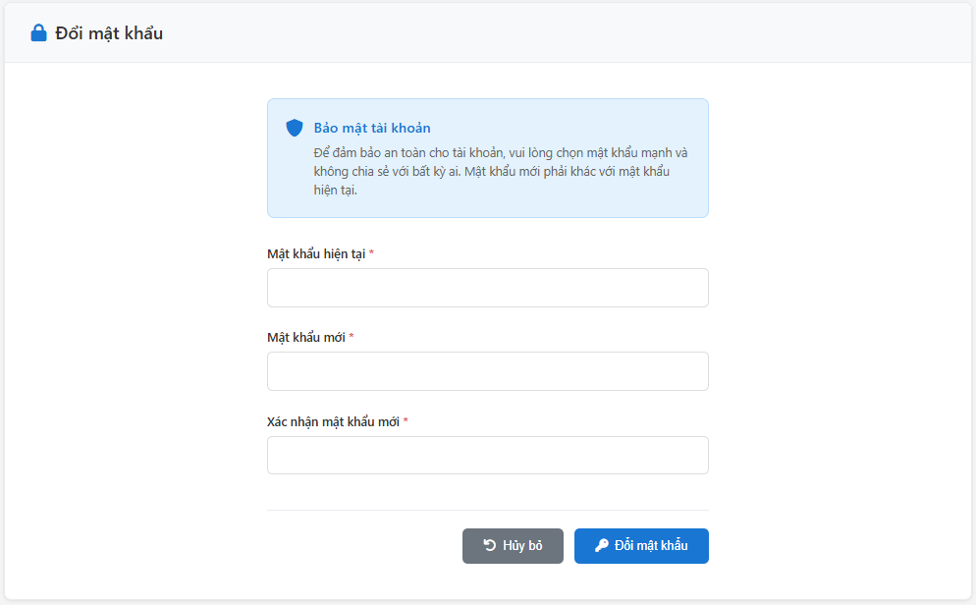

| **Field Name** | **Field Type** | **Description** |
| --- | --- | --- |
| Mật khẩu hiện tại | Password Input | Field for the user to enter their current password. It is a required field, indicated by the asterisk (*). |
| Mật khẩu mới | Password Input | Field for the user to enter their new desired password. It is a required field (*). The prompt suggests it should be strong and unique. |
| Xác nhận mật khẩu mới | Password Input | Field for the user to re-enter their new password to confirm it matches the "Mật khẩu mới" field. It is a required field (*). |
| Hủy bỏ | Button | Button to cancel the password change operation, likely returning the user to the previous screen or closing the form. |
| Đổi mật khẩu | Button | Button to submit the form and attempt to change the password. |

##### 

##### Database Access

##### 

| **Table** | **CRUD** | **Description** |
| --- | --- | --- |
| Users | U | Update new password of shop owner in their own database, and also new password of staffs |
| Shop Owner | U | Update new password of shop owner in admin database |

#### 2.2.2. Manage branches

This screen allows shop owners to view branch lists, update, delete or add new branches.

Related use cases:

* UC-6_Manage Branch

##### UI Design

*Branch list

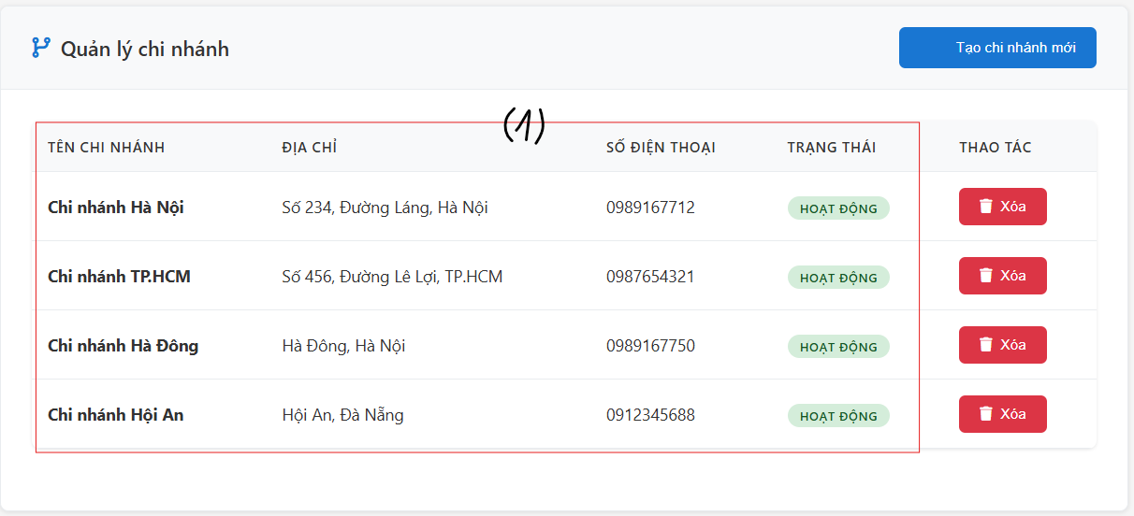

*Create new branch

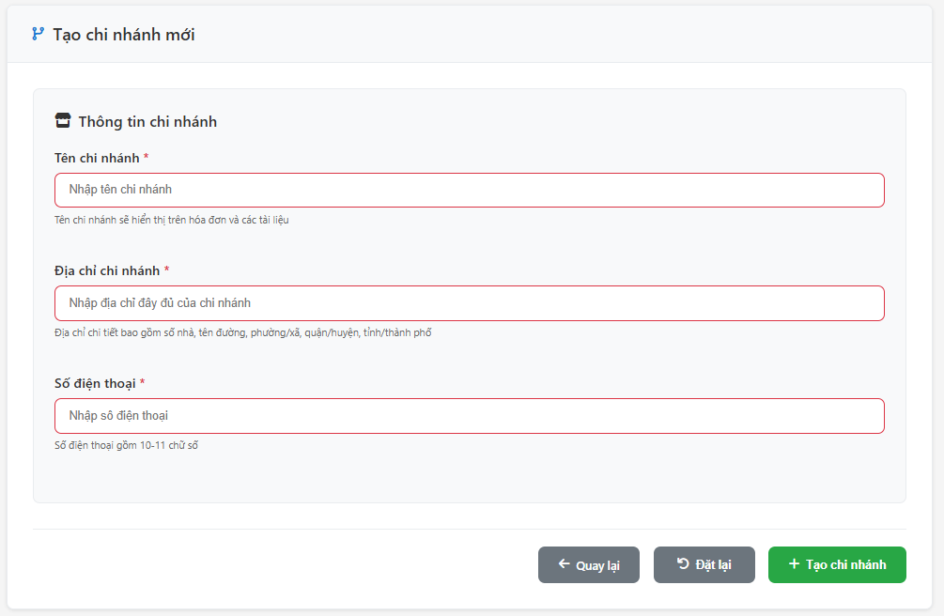

*Chỉnh sửa branch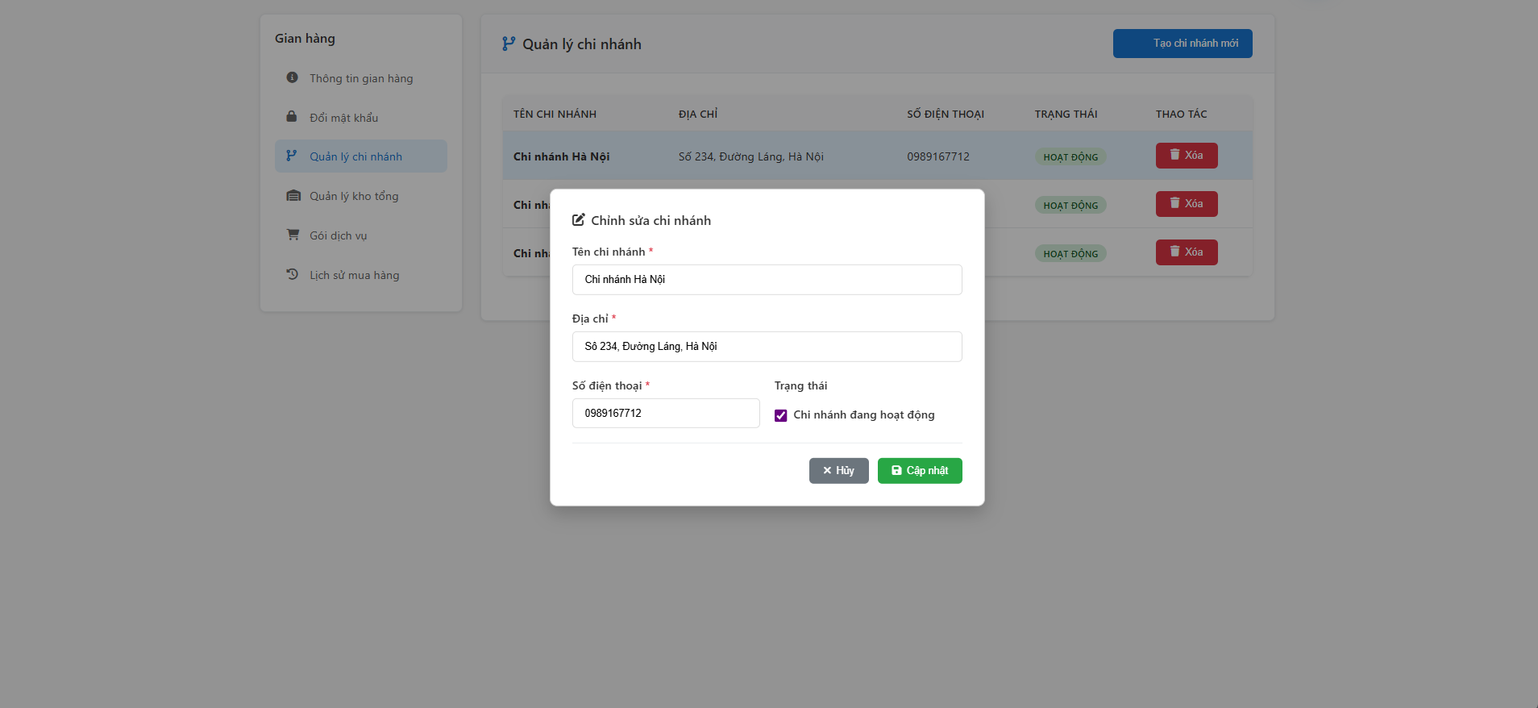

| **Field Name** | **Field Type** | **Description** |
| --- | --- | --- |
| ***Branch list Case*** | | |
| Tạo chi nhánh mới | Button | Button to initiate the process of creating a new branch. Clicking this leads to the "Tạo chi nhánh mới" (Create new branch) form. |
| Xoá | Button | Button to delete a branch |
| (1) | Text | Text fields show each branch information. |
| ***Branch creation Case*** | | |
| Tên chi nhánh* | Text Input | Field to enter the name of the new branch. It is a required field. |
| Địa chỉ chi nhánh* | Text Input | Field to enter the full address of the new branch. It is a required field. |
| Số điện thoại* | Text Input | Field to enter the phone number of the new branch. It is a required field. |
| Quay lại | Button | Button to go back to the branch list without creating a new branch. |
| Đặt lại | Button | Button to clear all entered information in the form fields. |
| Tạo chi nhánh | Button | Button to submit the form and create the new branch. |
| ***Branch update Case*** | | |
| Tên chi nhánh* | Text Input | Field to enter the new name of the branch |
| Địa chỉ chi nhánh* | Text Input | Field to enter the address of the branch |
| Số điện thoại* | Text Input | Field to enter the phone number of the branch |
| Huỷ | Button | Button to go back to the branch list without updating |
| Cập nhật | Button | Button to submit the form and update the branch |

##### Database Access

##### 

| **Table** | **CRUD** | **Description** |
| --- | --- | --- |
| Branches | C/R/U/D | Read the branches to get the branch list, then update details |
| Inventory | C/D |  |

#### 2.2.3. Manage warehouses

This screen allows shop owners to view warehouse lists, update, delete or add new warehouses.

Related use cases:

* UC-7_Manage Warehouse

##### UI Design

*Warehouse list

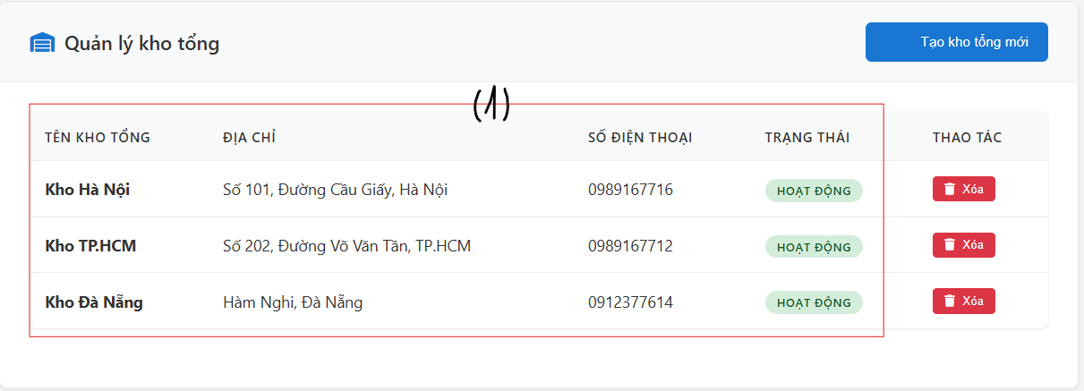

*Create new warehouse

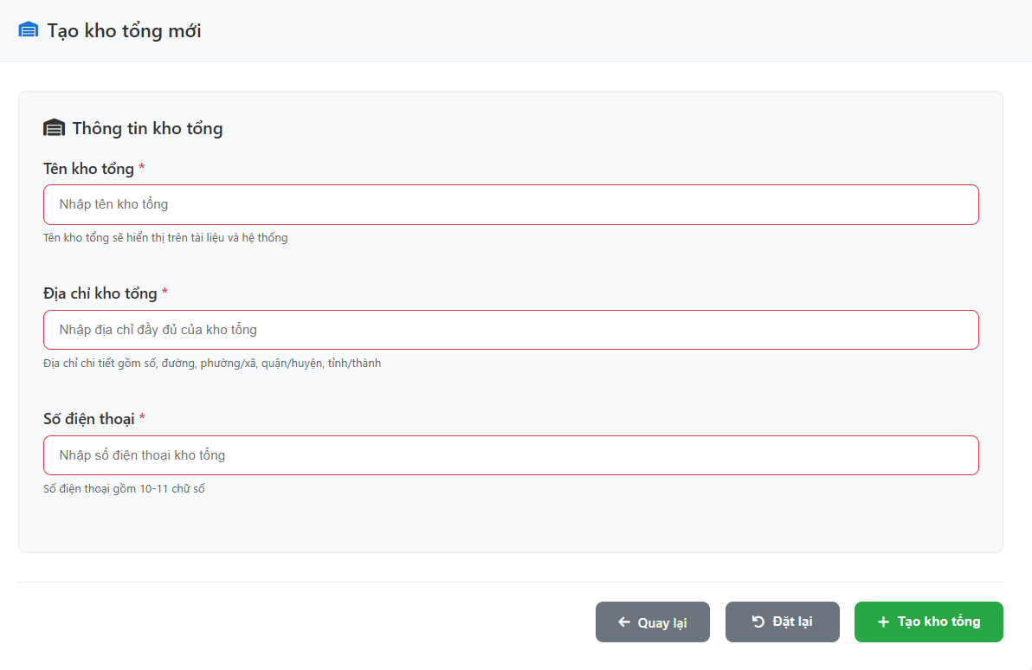

*Chỉnh sửa kho tổng



| **Field Name** | **Field Type** | **Description** |
| --- | --- | --- |
| ***Warehouse list Case*** | | |
| Tạo kho tổng mới | Button | Button to initiate the process of creating a new warehouse. Clicking this leads to the "Tạo kho tổng mới" (Create new warehouse) form. |
| Xoá | Button | Button to delete a warehouse. |
| (1) | Text | Text fields show each warehouse information. |
| ***Warehouse creation Case*** | | |
| Tên kho tổng* | Text Input | Field to enter the name of the new warehouse. It is a required field. |
| Địa chỉ kho tổng* | Text Input | Field to enter the full address of the new warehouse. It is a required field. |
| Số điện thoại* | Text Input | Field to enter the phone number of the new warehouse. It is a required field. |
| Quay lại | Button | Button to go back to the branch list without creating a new warehouse. |
| Đặt lại | Button | Button to clear all entered information in the form fields. |
| Tạo kho tổng | Button | Button to submit the form and create the new warehouse. |
| ***Warehouse update Case*** | | |
| Tên kho tổng* | Text Input | Field to enter the new name of the warehouse |
| Địa chỉ kho tổng* | Text Input | Field to enter the address of the warehouse |
| Số điện thoại* | Text Input | Field to enter the phone number of the warehouse |
| Huỷ | Button | Button to go back to the warehouse list without updating |
| Cập nhật | Button | Button to submit the form and update the warehouse |

##### 

##### Database Access

##### 

| **Table** | **CRUD** | **Description** |
| --- | --- | --- |
| Warehouses | C/R/U/D | Read the branches to get the warehouse list, then update details, or store new warehouse data created. |

#### 2.2.4. Subscribe services

This screen allows shop owners to view available service packages, select a desired subscription plan, provide their billing information, and complete the payment process to subscribe to services.

Related use cases:

* UC-8_Subscribe services

##### UI Design

*Select service screen

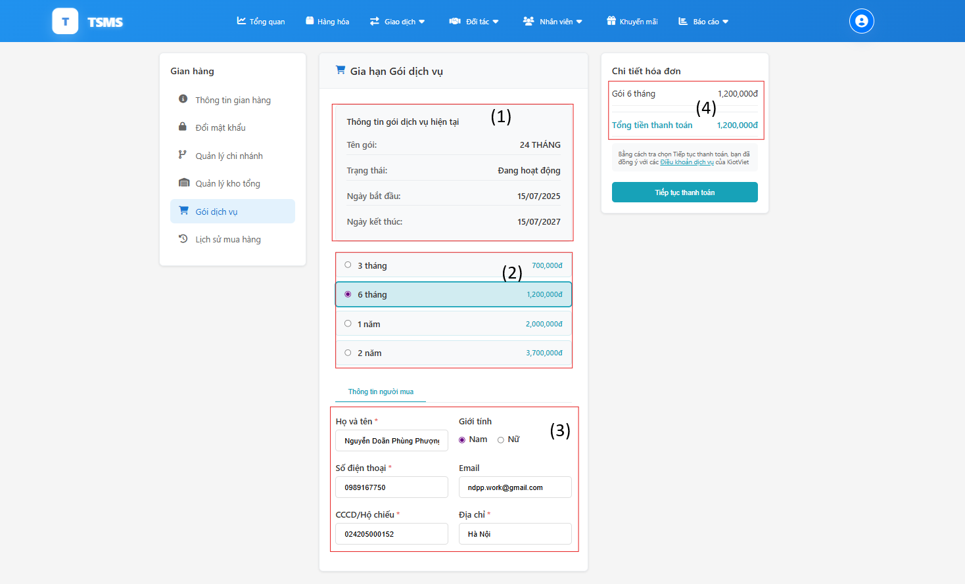

*Process payment screen

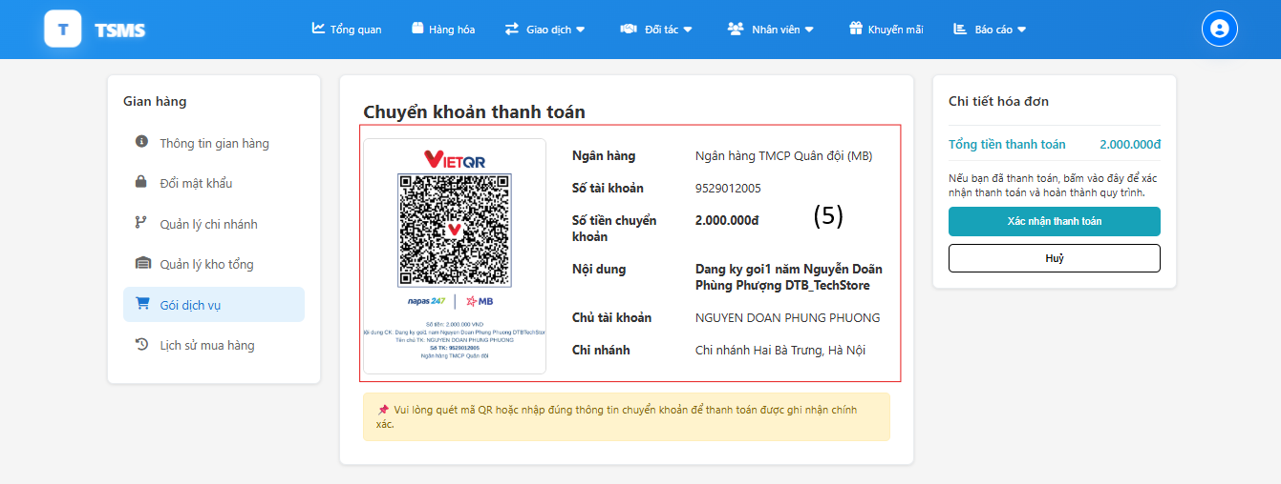

| **Field Name** | **Field Type** | **Description** |
| --- | --- | --- |
| ***Select service screen*** | | |
| (1) | Text | Current service package information |
| (2) | Radio buttons | Options for selecting service package duration (3 months, 6 months, 1 year, 2 years) and their corresponding prices. |
| (3) | Text fields | Buyer information: Full name, Gender, Phone number, Email, ID/Passport, Address. |
| (4) | Text | Invoice details: Selected package (e.g., Gói 6 tháng - 1,200,000đ), Total payment amount. |
| “Tiến hành thanh toán” | Button | Button to proceed with payment. |
| ***Process payment screen*** | | |
| (5) | Text | Banking information. |
| “Xác nhận thanh toán” | Button | Button to confirm payment completed. |

##### 

##### Database Access

##### 

| **Table** | **CRUD** | **Description** |
| --- | --- | --- |
| Subscription Logs | C | Record when a user subscribes to a service |
| UserServiceMethod | R | Read information about the service methods available to a user. |
| ShopOwner | R | Read information about the shop owner. |
| ServiceMethodPrice | R | Read the pricing details for different service methods. |

#### 2.2.5. View subscription logs

This screen allows shop owners to view subscription logs.

Related use cases:

* UC-9_View subscription logs

##### UI Design

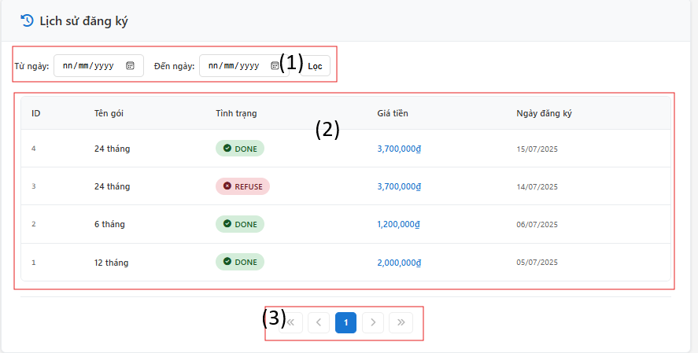

| **Field Name** | **Field Type** | **Description** |
| --- | --- | --- |
| (1) | Text and button | Date range filter (From date, To date) and a "Filter" button to apply the date range. |
| (2) | Text | Displays a list of registration history with columns: ID, Package Name, Status, Price, and Registration Date. |
| (3) | Button | Pagination controls (previous, next, page numbers) to navigate through multiple pages of registration history. |

##### 

##### Database Access

##### 

| **Table** | **CRUD** | **Description** |
| --- | --- | --- |
| Subscription Logs | R | Get all subscription logs of Shop Owner logged in. |

## 3. Shop/Branch Overview

This screen allows users to view the overview of the shop (if shop owner) and of each branch (if branch manager) .

Related use cases:

* UC-10_View overview

##### UI Design

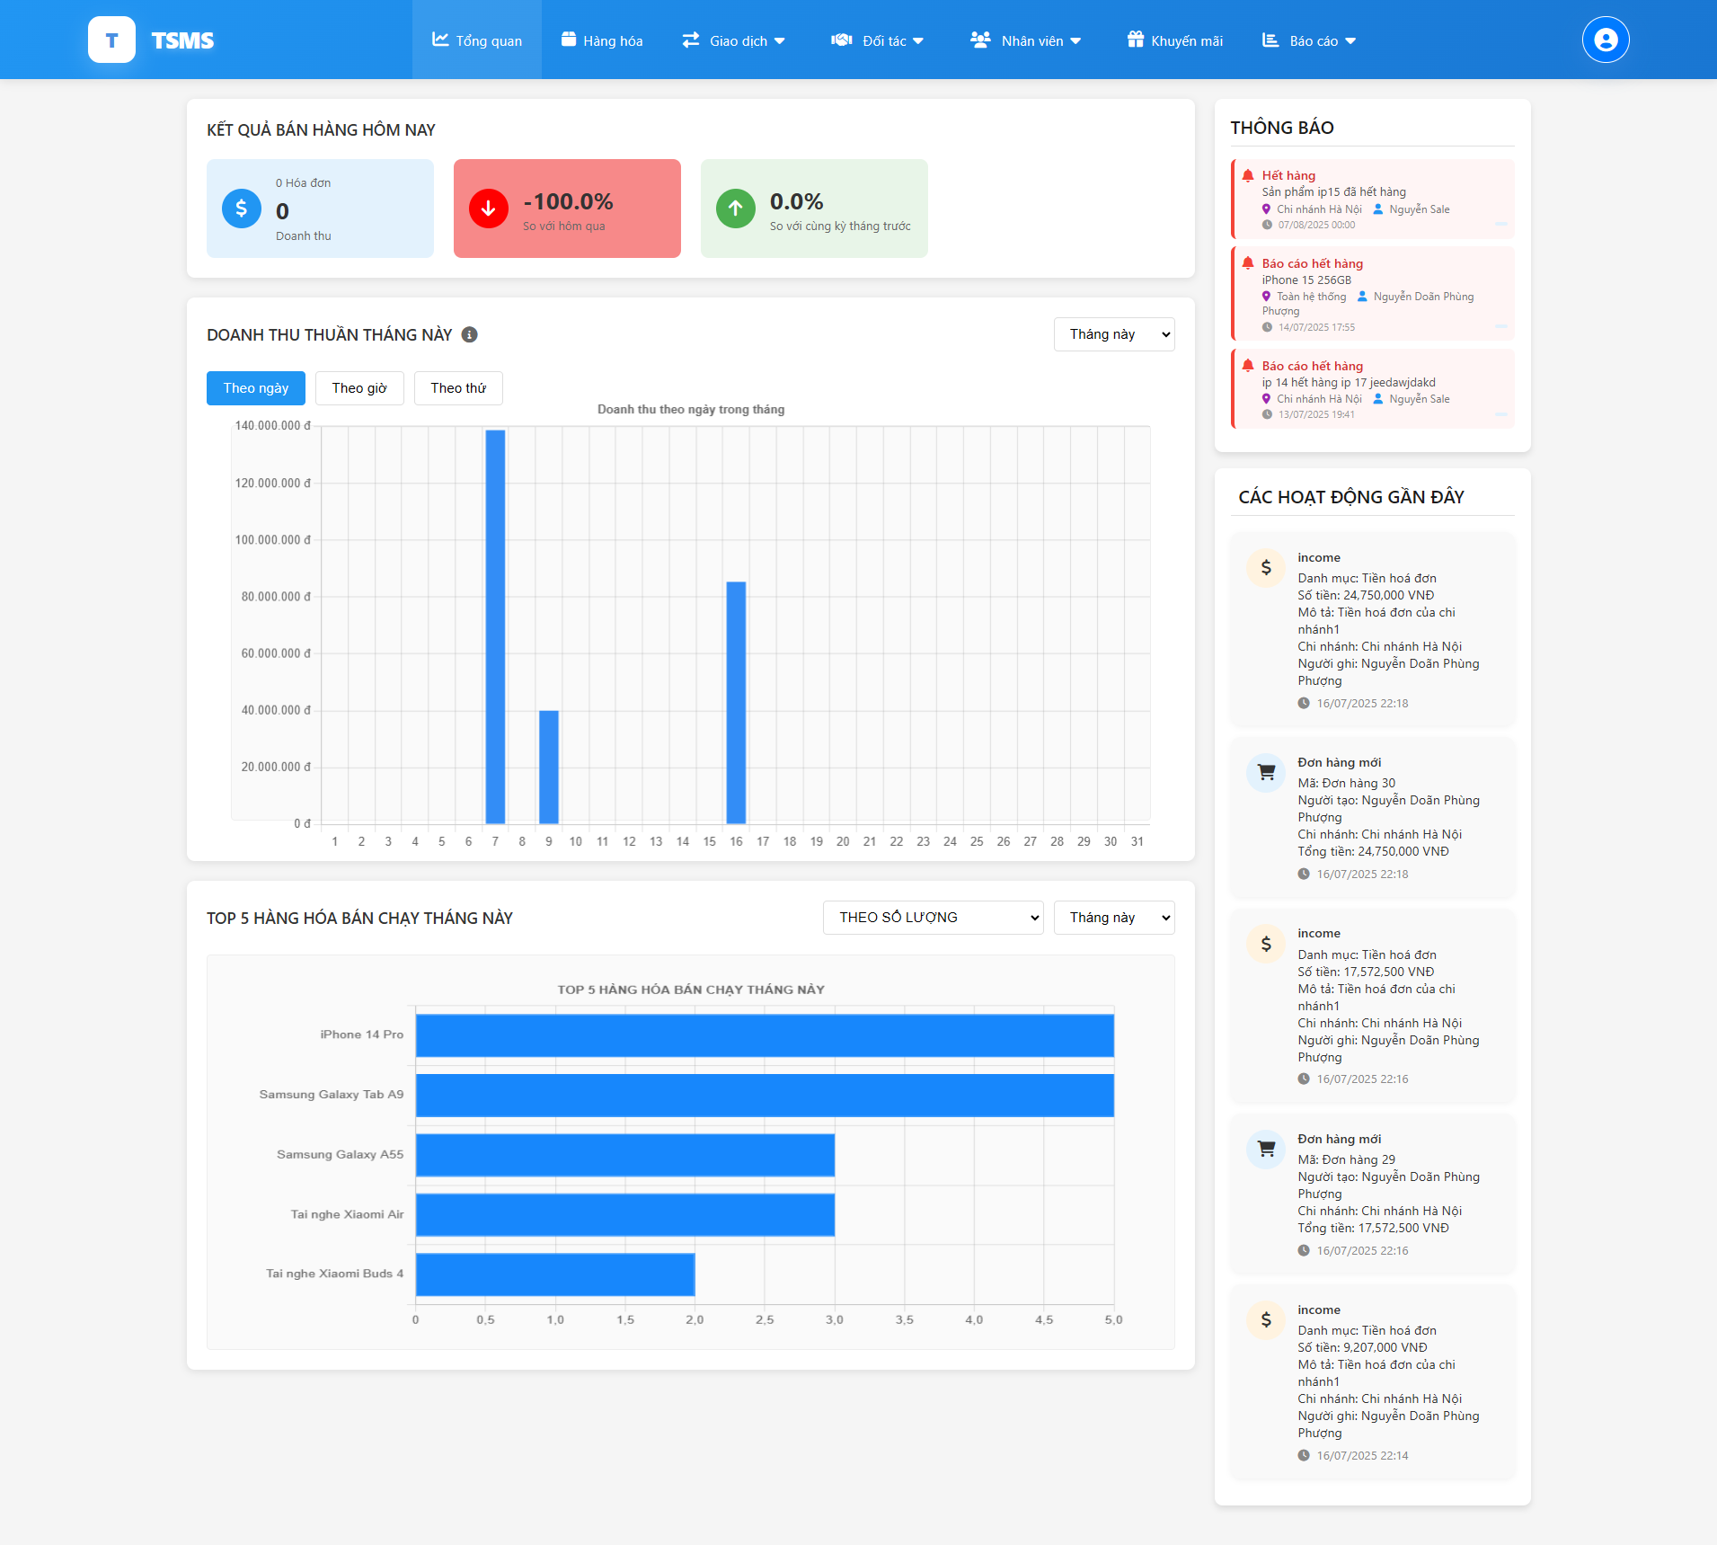

##### 

| Field Name | Field Type | Description |
| --- | --- | --- |
| sortBy | Select | Selection for sorting top products by quantity or net revenue |
| topPeriod | Select | Time period selection for top products (this month/last month) |
| period | Select | Time period selection for revenue chart (this month/last month) |
| filterType | Button | Filter for displaying revenue by day/hour/weekday |
| invoiceToDay | Display | Display number of invoices sold today |
| incomeTotal | Display | Display total formatted daily revenue |
| percentageChange | Display | Display percentage change in revenue compared to yesterday |
| monthlyChange | Display | Display percentage change compared to same period last month |
| monthlyChange | Display | Display percentage change compared to same period last month |
| revenueData | Object | Revenue chart data including labels, data and chartTitle |
| topProducts | List | List of top 5 best-selling products |
| recentAnnouncements | List | List of recent announcements from branches/warehouses |
| activityLogs | List | List of recent activities in the system |

##### 

##### Database Access

##### 

| **Table** | **CRUD** | **Description** |
| --- | --- | --- |
| CashFlows | R | Get revenue data for today, yesterday, same period last month, get revenue chart data by day/month/hour/weekday, get number of invoices for the day, get top 5 products data by quantity and revenue. |
| Orders | R | Get order information for revenue calculations |
| OrderDetails | R | Get order details for best-selling product analysis |
| ProductDetails | R | Get product information for top products report |
| Products | R | Get product names for display in reports |
| Announcements | R | Get list of recent announcements for chain owner |
| Users | R | Get information of announcement senders and activity creators |
| Branches | R | Get branch information related to announcements and activities |
| Warehouses | R | Get warehouse information related to announcements and activities |

## 4. Product Management

### 4.1 View products list

This screen allows users to view product lists in the system (with shop owner), in the warehouse (warehouse manager), in inventory (branch manager), they can filter or search the products.

Related use cases:

* UC-11_View products list

##### UI Design

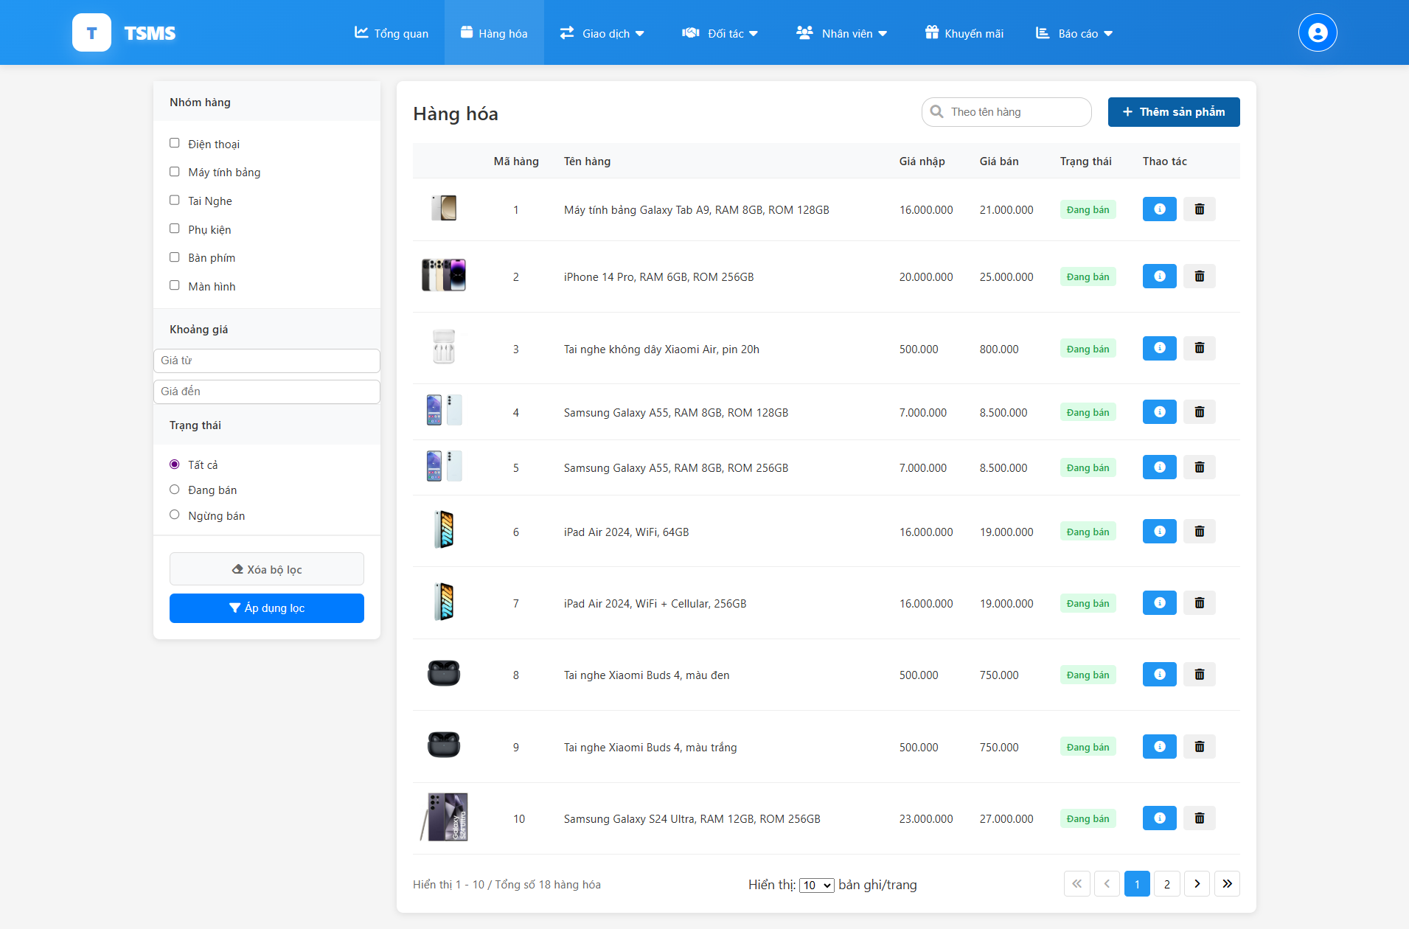

| **Field Name** | **Field Type** | **Description** |
| --- | --- | --- |
| Giá từ | Input | To input the start price of the price range filter. |
| Giá đến | Input | To input the end price of the price range filter. |
| Nhóm hàng | Checkbox | To filter product list by category. |
| Tìm kiếm | Input | To search for products in the list. |

##### 

##### Database Access

##### 

| **Table** | **CRUD** | **Description** |
| --- | --- | --- |
| Products | R | Get comprehensive product information |
| ProductDetails | R | Get detailed product information |
| InventoryProducts | R | Get product quantity in inventory of each branch, displayed in branch manager accounts. |
| WarehouseProducts | R | Get product quantity in each warehouse, displayed in warehouse manager accounts. |

### 

### 4.2 View product detail

This screen allows users to view product detail and they will be able to edit then update that product.

Related use cases:

* UC-12_Update product

##### UI Design

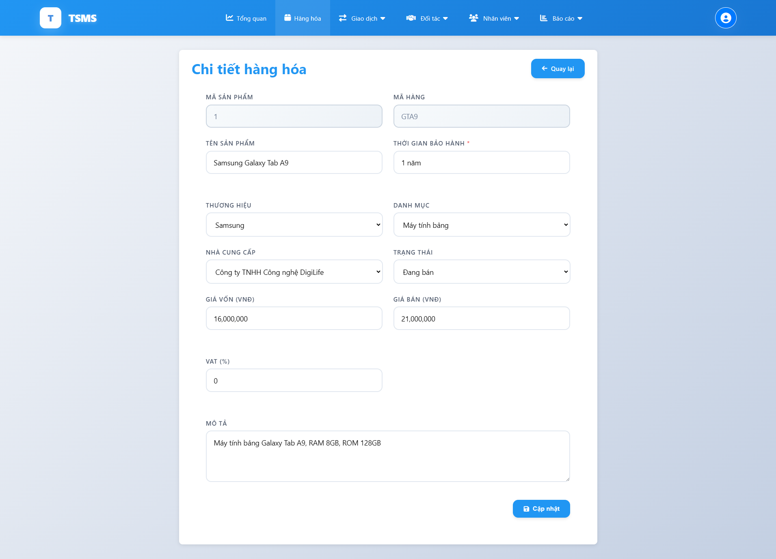

| **Field Name** | **Field Type** | **Description** |
| --- | --- | --- |
| Mã hàng | Text (Readonly) | Product ID |
| Mã sản phẩm | Integer (Readonly) | System-assigned product number |
| Tên sản phẩm | Text | Name of the product |
| Thời gian bảo hành | Text | Warranty period |
| Thương hiệu | Text (Dropdown) | Brand of the product |
| Danh mục | Text (Dropdown) | Product category |
| Nhà cung cấp | Text (Dropdown) | Supplier of the product |
| Trạng thái | Text (Dropdown) | Status of the product |
| Giá vốn (VND) | Currency (VND) | Cost price of the product |
| Giá bán (VND) | Currency (VND) | Selling price of the product |
| VAT (%) | Integer | Value Added Tax percentage |
| Mô tả | Text (Multiline) | Detailed description of the product |

##### 

##### Database Access

##### 

| **Table** | **CRUD** | **Description** |
| --- | --- | --- |
| Products | R | Get comprehensive product information |
| ProductDetails | R | Get detailed product information |

### 4.3 Add product

This screen allows users to add a new product, brand, category or supplier into the shop chain.

Related use cases:

* UC-13_Add product

##### UI Design

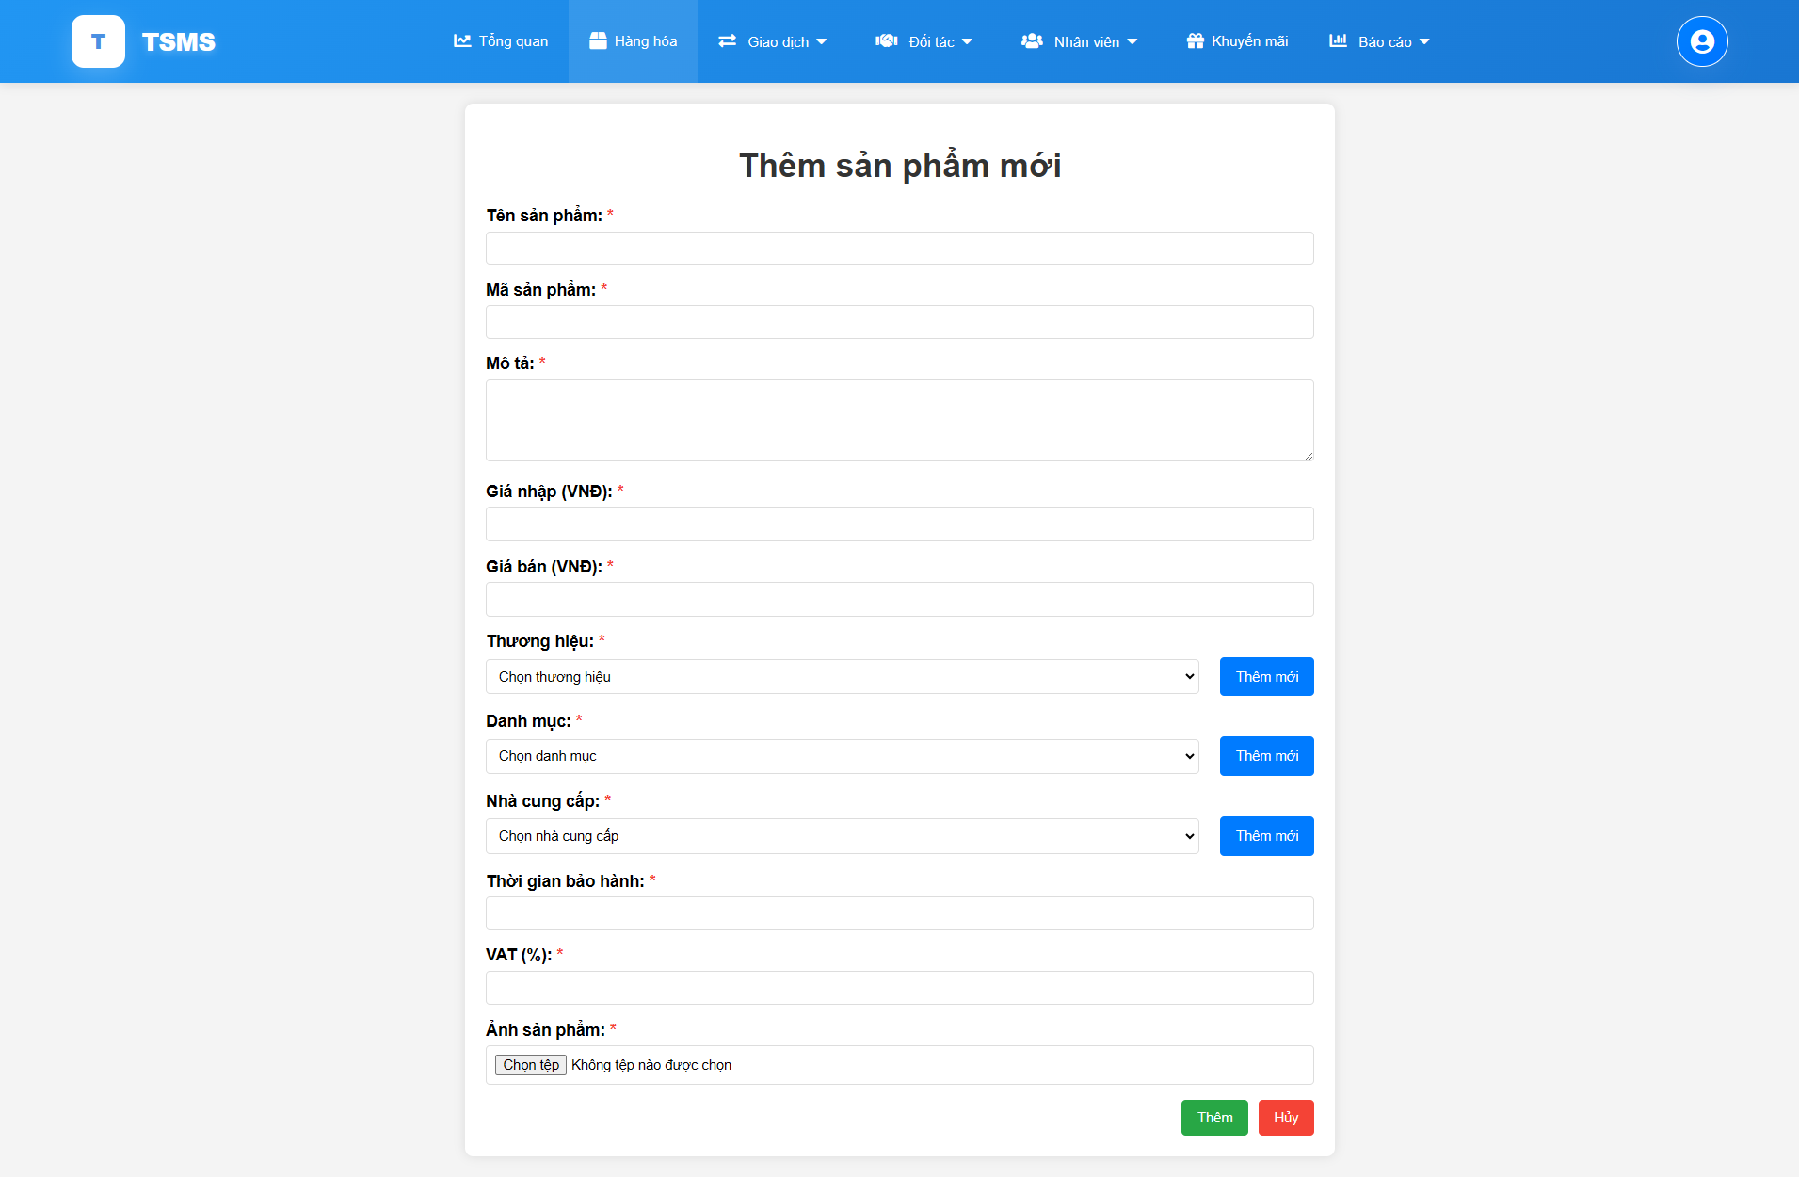

| **Field Name** | **Field Type** | **Description** |
| --- | --- | --- |
| Tên sản phẩm | Text Input | Name of the product (required) |
| Mã sản phẩm | Text Input | Unique product code/ID (required) |
| Mô tả | Multiline Text Input | Detailed description of the product (required) |
| Giá nhập (VND) | Number/Currency Input | Purchase price of the product in VND (required) |
| Giá bán (VND) | Number/Currency Input | Selling price of the product in VND (required) |
| Thương hiệu | Dropdown + Button | Brand of the product (required, with an option to add new) |
| Danh mục | Dropdown + Button | Category of the product (required, with an option to add new) |
| Nhà cung cấp | Dropdown + Button | Supplier of the product (required, with an option to add new) |
| Thời gian bảo hành | Text Input | Warranty period for the product (required) |
| VAT (%) | Number Input | Value Added Tax percentage (required) |
| Ảnh sản phẩm | File Upload | Image(s) of the product (required) |

##### 

##### Database Access

##### 

| **Table** | **CRUD** | **Description** |
| --- | --- | --- |
| Products | C | To insert core information of each product. |
| ProductDetails | C | To insert additional details of products. |
| Categories | C/R | Get a list of categories for a new product. Allows creating new categories. |
| Brands | C/R | Get a list of brands for a new product. Allows creating new brands. |
| Suppliers | C/R | Get a list of suppliers for a new product. Allows creating new suppliers. |

## 5. Order Management

### 5.1 View order list

This screen allows users to view order lists overall or in a selected branch (with shop owner), in each branch(branch manager), they can filter or search the order.

Related use cases:

* UC-14_View order list

##### UI Design

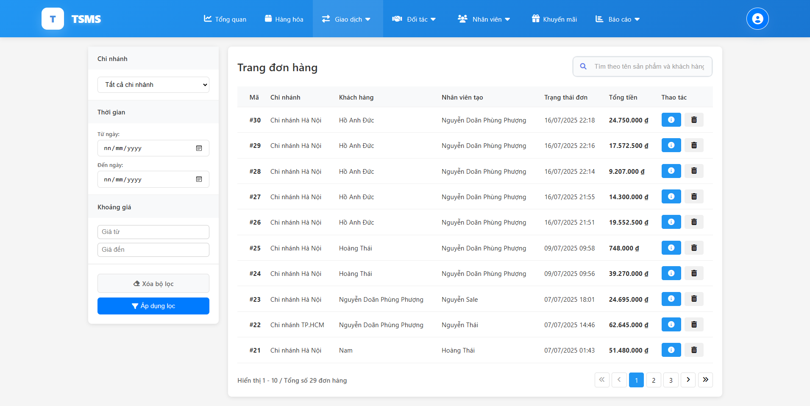

| **Field Name** | **Field Type** | **Description** |
| --- | --- | --- |
| Chi nhánh | Dropdown | Allows filtering orders by branch |
| Từ ngày | Date Picker | Start date for filtering orders |
| Đến ngày | Date Picker | End date for filtering orders |
| Giá từ | Number Input | Minimum price for filtering orders by total amount |
| Giá đến | Number Input | Maximum price for filtering orders by total amount |
| Xóa bộ lọc | Button | Clears all applied filters |
| Áp dụng lọc | Button | Applies the selected filters to the order list |
| Tìm kiếm | Input | To search for order in the list. |

##### 

##### Database Access

##### 

| **Table** | **CRUD** | **Description** |
| --- | --- | --- |
| Orders | R | Get the list of order with overall information |

### 5.2 View order detail

This screen allows users to view details of a selected order.

Related use cases:

* UC-15_View order detail

##### UI Design

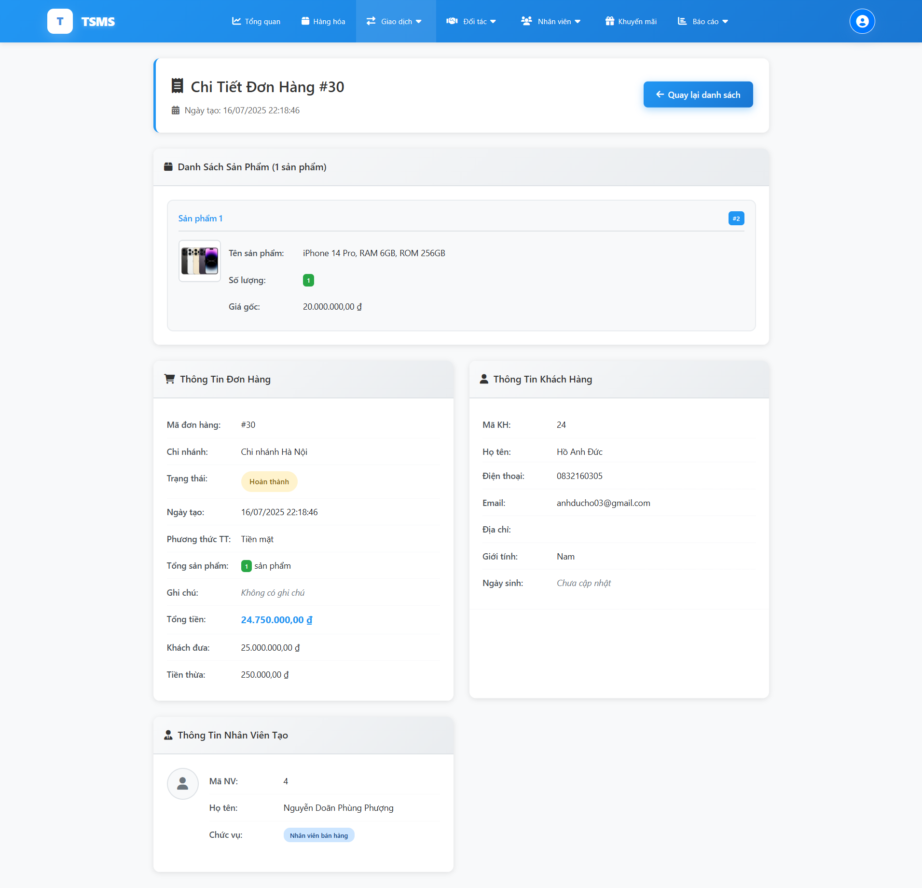

| **Field Name** | **Field Type** | **Description** |
| --- | --- | --- |
| ***Danh sách Sản phẩm*** | | |
| Tên sản phẩm | Text | Name of the product in the order |
| Số lượng | Integer | Quantity of the product ordered |
| Giá gốc | Currency (VND) | Original price of the product |
| ***Thông Tin Đơn Hàng*** | | |
| Mã đơn hàng | Text | Unique identifier for the order |
| Chi nhánh | Text | Branch where the order was placed |
| Trạng thái | Text (Status) | Current status of the order |
| Ngày tạo | Date/Time | Date and time the order was created |
| Phương thức TT | Text | Payment method |
| Tổng sản phẩm | Integer | Total number of distinct products in the order |
| Ghi chú | Text | Any notes or remarks for the order |
| Tổng tiền | Currency (VND) | Total amount of the order |
| Khách đưa | Currency (VND) | Amount paid by the customer |
| Tiền thừa | Currency (VND) | Change to be given back to the customer |
| ***Thông Tin Khách Hàng*** | | |
| Mã KH | Integer | Customer ID |
| Họ tên | Text | Full name of the customer |
| Điện thoại | Text | Customer's phone number |
| Email | Text | Customer's email address |
| Địa chỉ | Text | Customer's address |
| Giới tính | Text | Customer's gender |
| Ngày sinh | Date | Customer's date of birth |
| ***Thông Tin Khách Hàng*** | | |
| Mã NV | Integer | Employee ID of the person who created the order |
| Họ tên | Text | Full name of the employee |
| Chức vụ | Text | Employee's position/role |

##### Database Access

| **Table** | **CRUD** | **Description** |
| --- | --- | --- |
| Orders | R | Used to retrieve the main information of each order. |
| OrderDetails | R | Used to fetch the specific line items within an order. |
| Customers | R | Used to retrieve customer information associated with an order or to display customer profiles. |
| Products | R | Used to fetch general product information to display in order details or product lists. |
| Staffs | R | Used to retrieve information about the staff involved in creating or processing orders. |
| ProductDetails | R | Used to fetch detailed specifications or attributes of a product. |

## 6. Partner Management

### 6.1 View customer list

This screen allows users to view a list of customers with their basic information.

Related use cases:

* UC-16_View customer list

##### UI Design

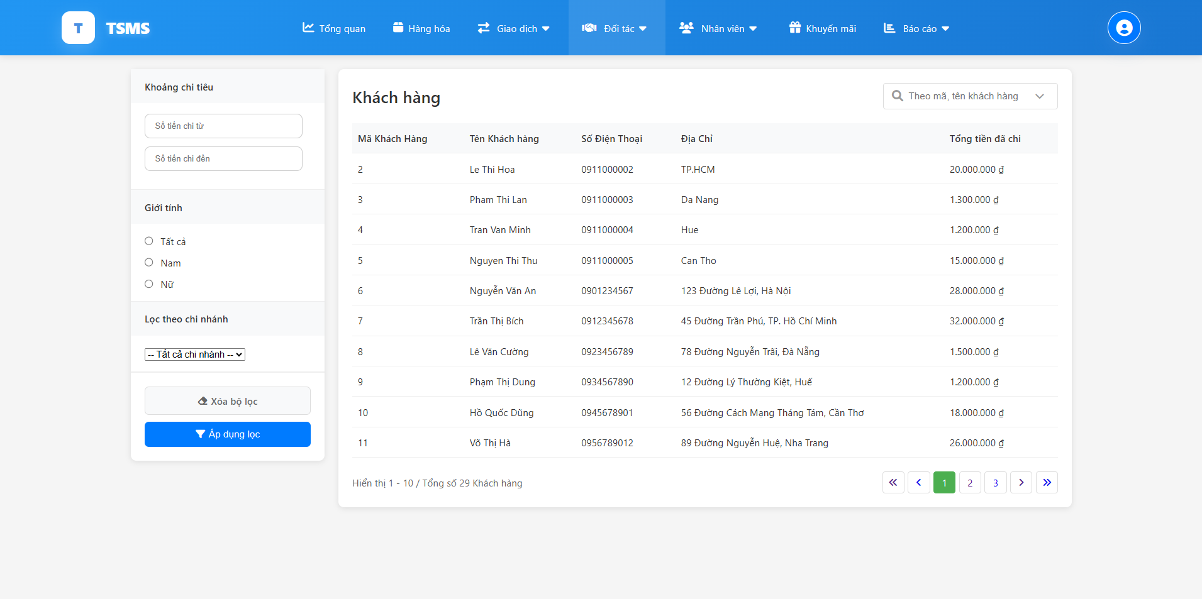

| **Field Name** | **Field Type** | **Description** |
| --- | --- | --- |
| Số tiền chi từ | Number Input | Minimum amount spent by the customer for filtering. |
| Số tiền chi đến | Number Input | Maximum amount spent by the customer for filtering. |
| Giới tính | Radio Button | Allows filtering customers by gender. |
| Lọc theo chi nhánh | Dropdown | Allows filtering customers by the branch they are associated with |
| Tìm kiếm | Input | Search for customers. |
| Xóa bộ lọc | Button | Resets all applied filters for customers. |
| Áp dụng lọc | Button | Applies the selected filters to the customer list. |

##### 

##### Database Access

##### 

| **Table** | **CRUD** | **Description** |
| --- | --- | --- |
| Customers | R | Used to retrieve customer information. |
| Orders | R | Used to count the total spent of each customer. |

### 6.2 Update customer details

This screen allows users to view the detailed information of a specific customer. It also provides an option to save any edits made to the customer's information.

Related use cases:

* UC-17_View and edit customer detail

##### UI Design

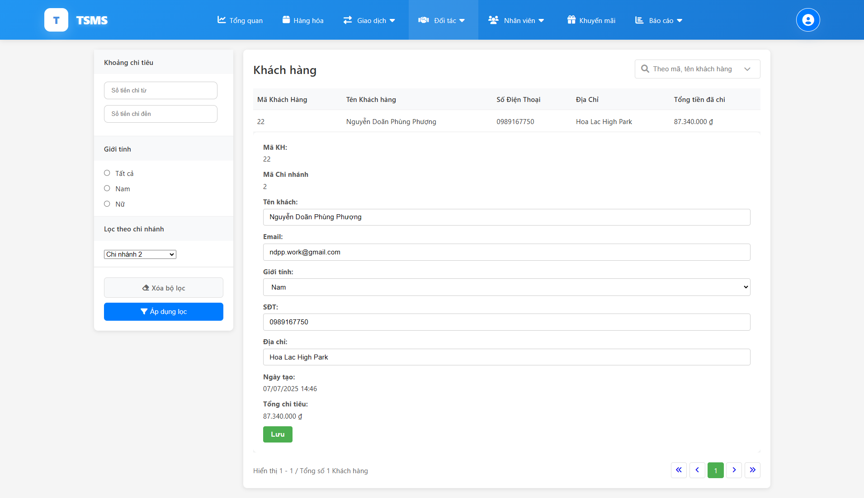

| **Field Name** | **Field Type** | **Description** |
| --- | --- | --- |
| Mã KH | Integer | Unique identifier for the customer |
| Mã Chi nhánh | Integer | Identifier for the branch associated with the customer |
| Tên khách | Text | Full name of the customer |
| Email | Text | Email address of the customer |
| Giới tính | Dropdown | Gender of the customer |
| SĐT | Text | Phone number of the customer |
| Địa chỉ | Text | Address of the customer |
| Ngày tạo | Date/Time | Date and time when the customer record was created |
| Tổng chi tiêu | Currency (VND) | Total amount spent by the customer |
| Lưu | Button | Action to save changes to the customer's information |

##### 

##### Database Access

##### 

| **Table** | **CRUD** | **Description** |
| --- | --- | --- |
| Customers | R | Used to retrieve customer information. |
| Orders | R | Used to count the total spent of each customer. |

### 6.3 View supplier list

This screen allows users to view ….

Related use cases:

* UC-18_View supplier list

##### UI Design

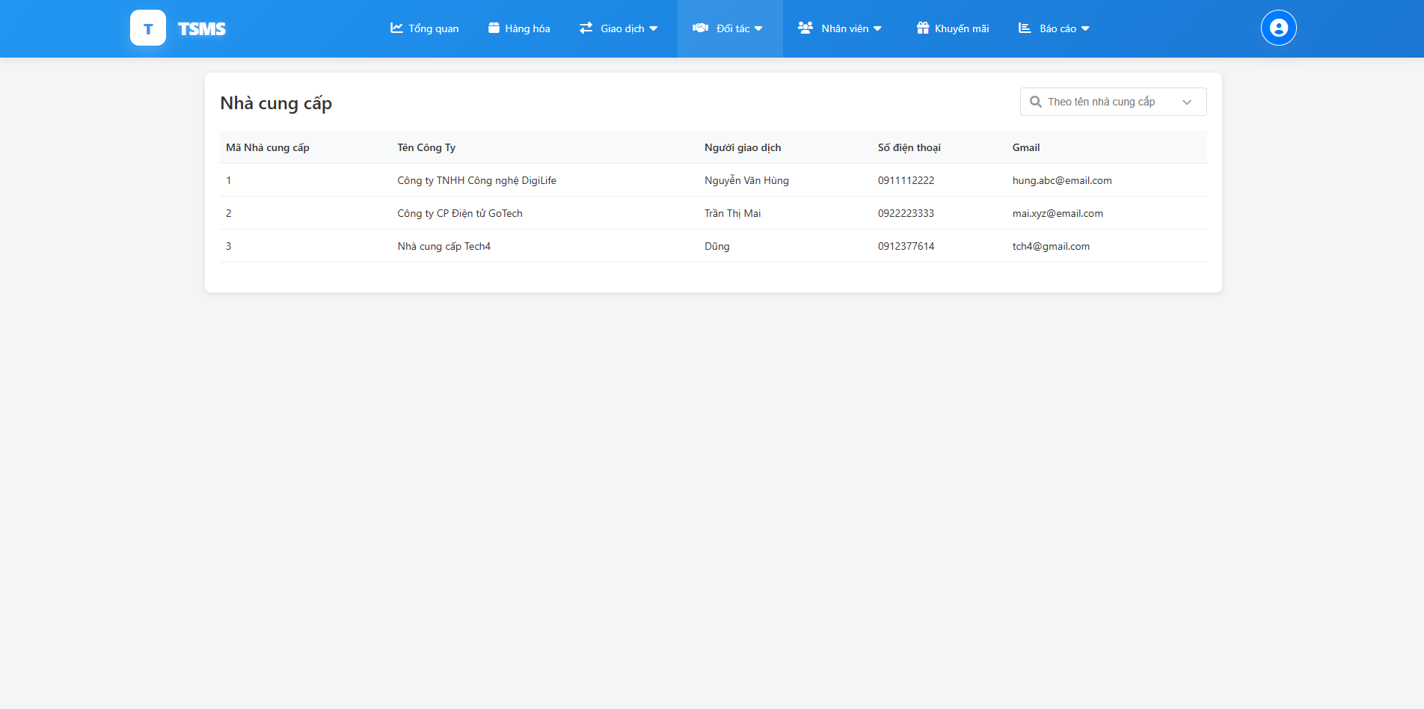

| **Field Name** | **Field Type** | **Description** |
| --- | --- | --- |
| Tìm kiếm | Input | Search for customers. |

##### 

##### Database Access

##### 

| **Table** | **CRUD** | **Description** |
| --- | --- | --- |
| Suppliers | R | Used to retrieve supplier information. |

## 7. Staff Management

### 7.1 View staff list

This screen allows users to view staff lists in the whole shop chain.

Related use cases:

* UC-19_View staff list

##### UI Design

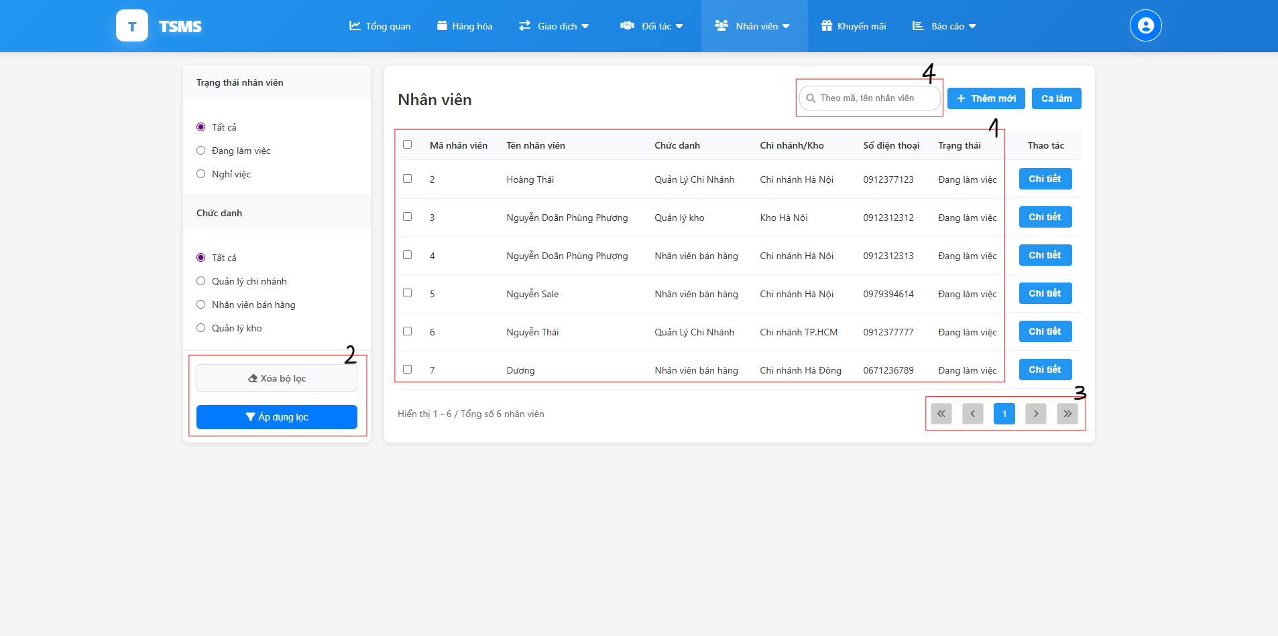

| **Field Name** | **Field Type** | **Description** |
| --- | --- | --- |
| Trạng thái nhân viên | Radio Button | Allows filtering staff by their employment status |
| Chức danh | Radio Button | Allows filtering staff by their role/position |
| (1) | Text | Show the staff information |
| (2) | Button | Applies or clear the selected filters to the staff list |
| (3) | Button | Used to paging |
| (4) | Text input | Search the staff |
| Thêm mới | Button | Used to add a new staff |
| Ca làm | Button | Used to redirect to a shift plan page |

##### 

##### Database Access

##### 

| **Table** | **CRUD** | **Description** |
| --- | --- | --- |
| Staffs | R | Used to retrieve all staff information. |

### 7.2 Update staff details

This screen allows users to view ….

Related use cases:

* UC-20_View & edit staff details

##### UI Design

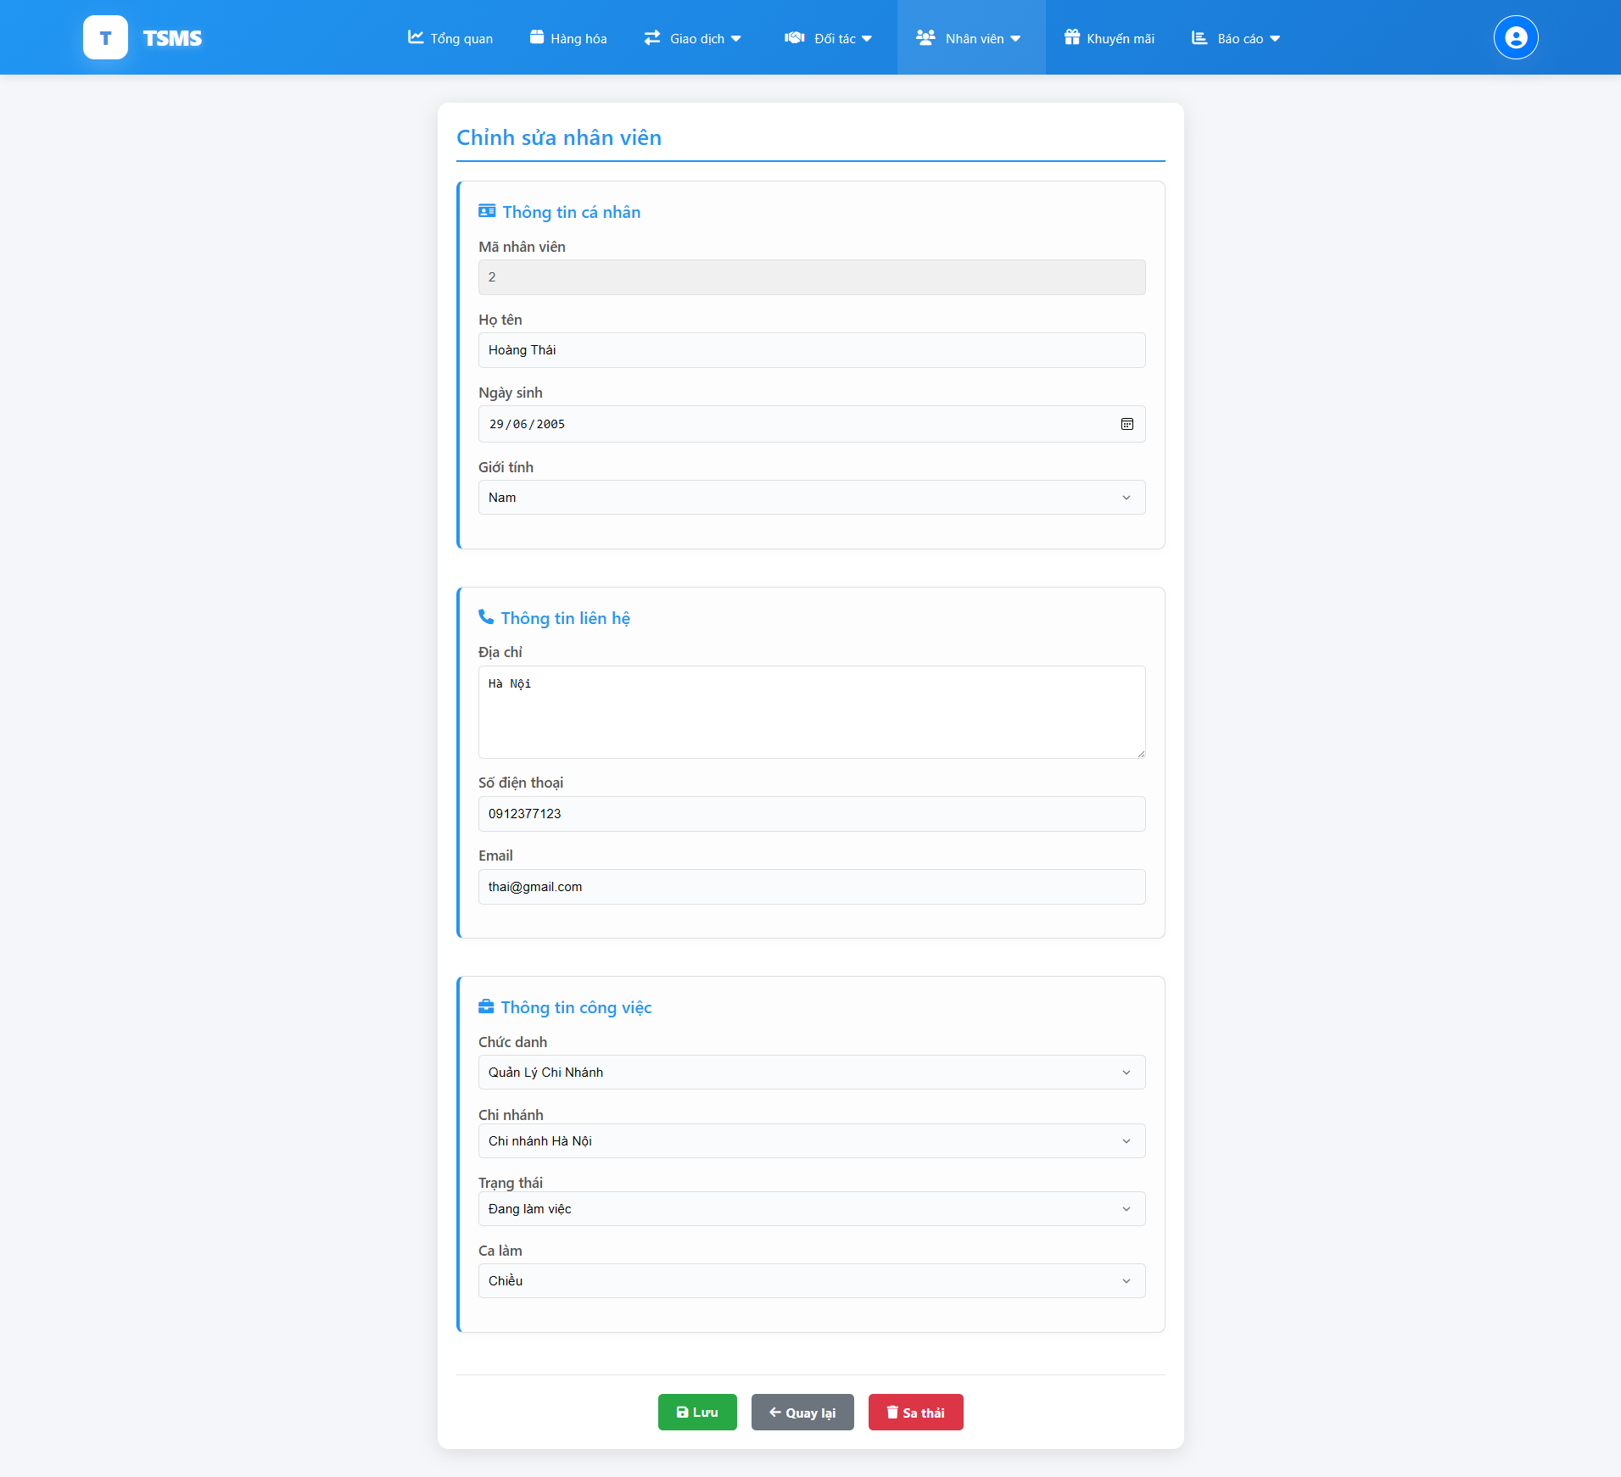

| **Field Name** | **Field Type** | **Description** |
| --- | --- | --- |
| Mã nhân viên | Integer | Show unique identifiers of the staff. |
| Họ tên | Text | Show full name of the staff. |
| Ngày sinh | Date | Show date of birth of the staff member. |
| Giới tính | Dropdown | Show gender of the staff member. |
| Địa chỉ | Text | Show current address of the staff member. |
| Số điện thoại | Text | Show contact phone number of the staff member. |
| Email | Text | Show email address of the staff member. |
| Chức danh | Dropdown | Show the role or title of the staff member. |
| Chi nhánh | Dropdown | Show the branch or location where the staff member works. |
| Trạng thái | Dropdown | Show current employment status of the staff member. |
| Ca làm | Dropdown | Show the work shift of the staff member. |
| Lưu | Button | Saves the updated staff member information. |
| Quay lại | Button | Navigates back without saving changes. |
| Sa thải | Button | Lay off the employee |

##### 

##### Database Access

##### 

| **Table** | **CRUD** | **Description** |
| --- | --- | --- |
| Staffs | R | Used to retrieve selected staff information. |

### 

### 7.3 Add a new staff

This screen allows users to add a new staff, fill in some basic information of a new staff to complete the process.

Related use cases:

* UC-21_Add staff

##### UI Design

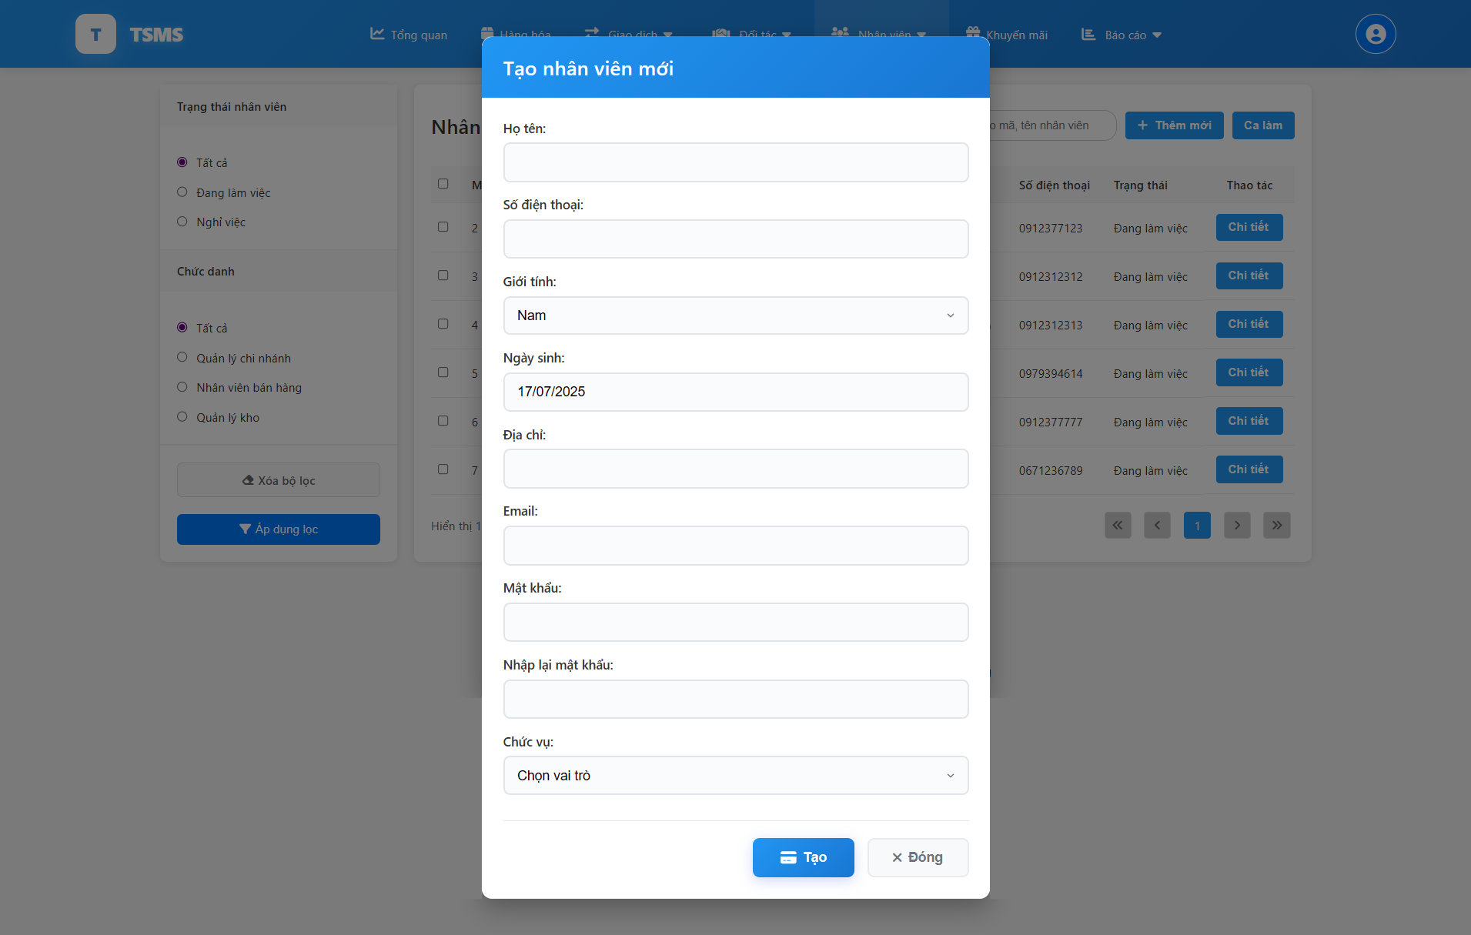

| **Field Name** | **Field Type** | **Description** |
| --- | --- | --- |
| Họ tên | Text Input | Full name of the new staff member (required). |
| Số điện thoại | Text Input | Phone number of the new staff member (required). |
| Giới tính | Dropdown | Gender of the new staff member (required). |
| Ngày sinh | Date Picker | Date of birth of the new staff member (required). |
| Địa chỉ | Text Input | Residential address of the new staff member (required). |
| Email | Text Input | Email address of the new staff member (required). |
| Mật khẩu | Password Input | Password for the new staff member's account (required). |
| Nhập lại mật khẩu | Password Input | Confirmation of the password (required). |
| Chức vụ | Dropdown | Role or position of the new staff member (required). |
| Tạo | Button | Creates the new staff member record. |
| Đóng | Button | Closes the "Create new staff member" form without saving. |

##### 

##### Database Access

##### 

| **Table** | **CRUD** | **Description** |
| --- | --- | --- |
| Staffs | C | To insert a new staff into the system |
| Branches | R | Get a list of branches, used for adding workplaces for employees being created |
| Warehouses | R | Get a list of warehouses, used for adding workplaces for employees being created |

### 7.4 View shift list

This screen allows shop owners to view a list of all defined work shifts, including their ID, name, start time, end time, and total duration. It also provides functionality to add new work shifts, navigate to staff management, and perform actions like editing or deleting existing shifts.

Related use cases:

* UC-22_View shift list

##### UI Design

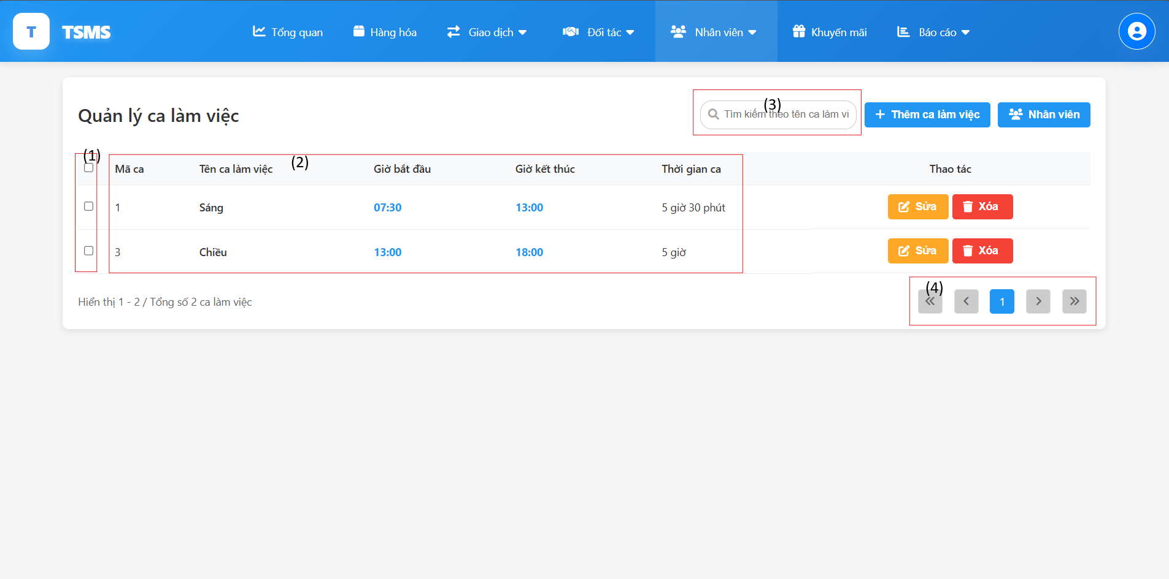

| **Field Name** | **Field Type** | **Description** |
| --- | --- | --- |
| Thêm ca làm việc | Button | Button to add a new work shift. |
| Nhân viên | Button | Button to navigate to the staff management section. |
| Sửa | Button | Action button to edit a specific work shift. |
| Xoá | Button | Action button to delete a specific work shift. |
| (1) | Checkbox | Checkbox used to select individual work shifts. |
| (2) | Text | Shift information list. |
| (3) | Input | Text input field for searching work shifts by name. |
| (4) | Button | Navigation buttons for pagination. |

##### 

##### Database Access

##### 

| **Table** | **CRUD** | **Description** |
| --- | --- | --- |
| Shift | R | Used to retrieve all shift information. |

### 7.5 Update Shift Details

This screen allows shop owners to edit existing work shifts by modifying their name, start time, and end time.

Related use cases:

* UC-23_Update shift

##### UI Design

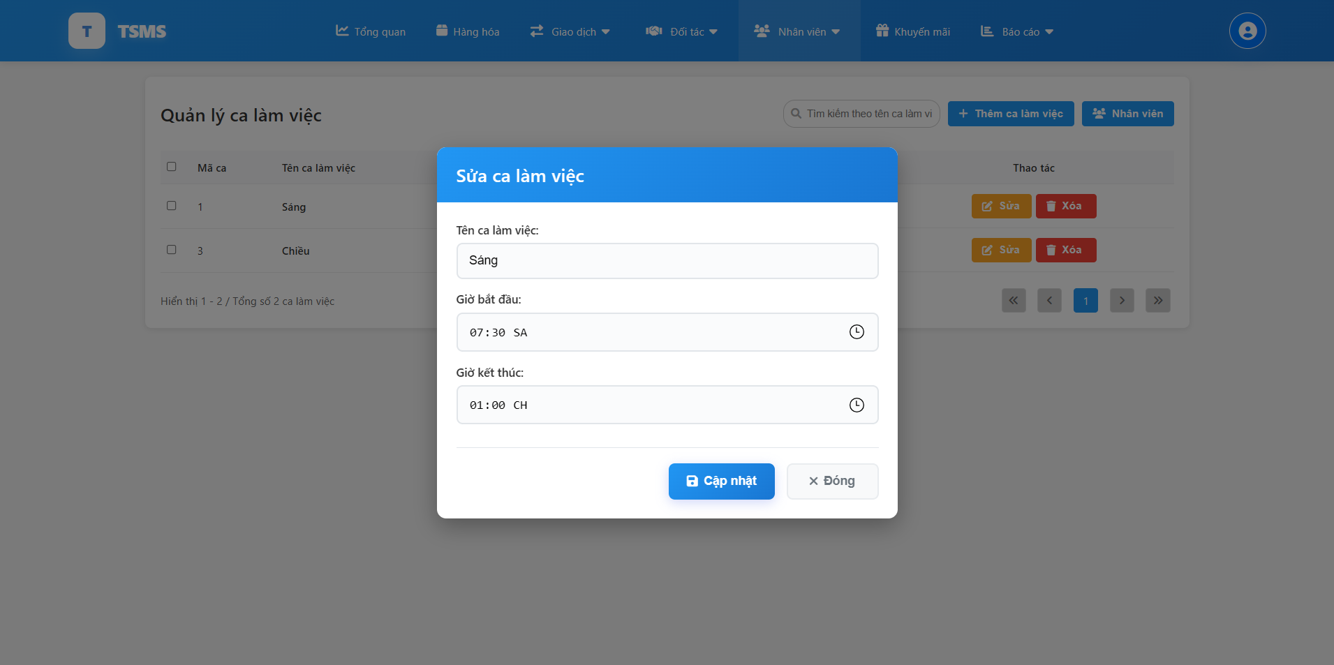

| **Field Name** | **Field Type** | **Description** |
| --- | --- | --- |
| Tên ca làm việc | Text Input | The name of the work shift |
| Giờ bắt đầu | Time Input | The starting time of the work shift |
| Giờ kết thúc | Time Input | The ending time of the work shift |
| Cập nhật | Button | Button to save the changes to the work shift. |
| Đóng | Button | Button to close the pop-up without saving changes. |

##### Database Access

##### 

| **Table** | **CRUD** | **Description** |
| --- | --- | --- |
| Shift | U | Used to update new details of selected work shift |

### 7.6 Create a new shift

This screen allows shop owners to create a new work shift.

Related use cases:

* UC-24_Create a new shift

##### UI Design

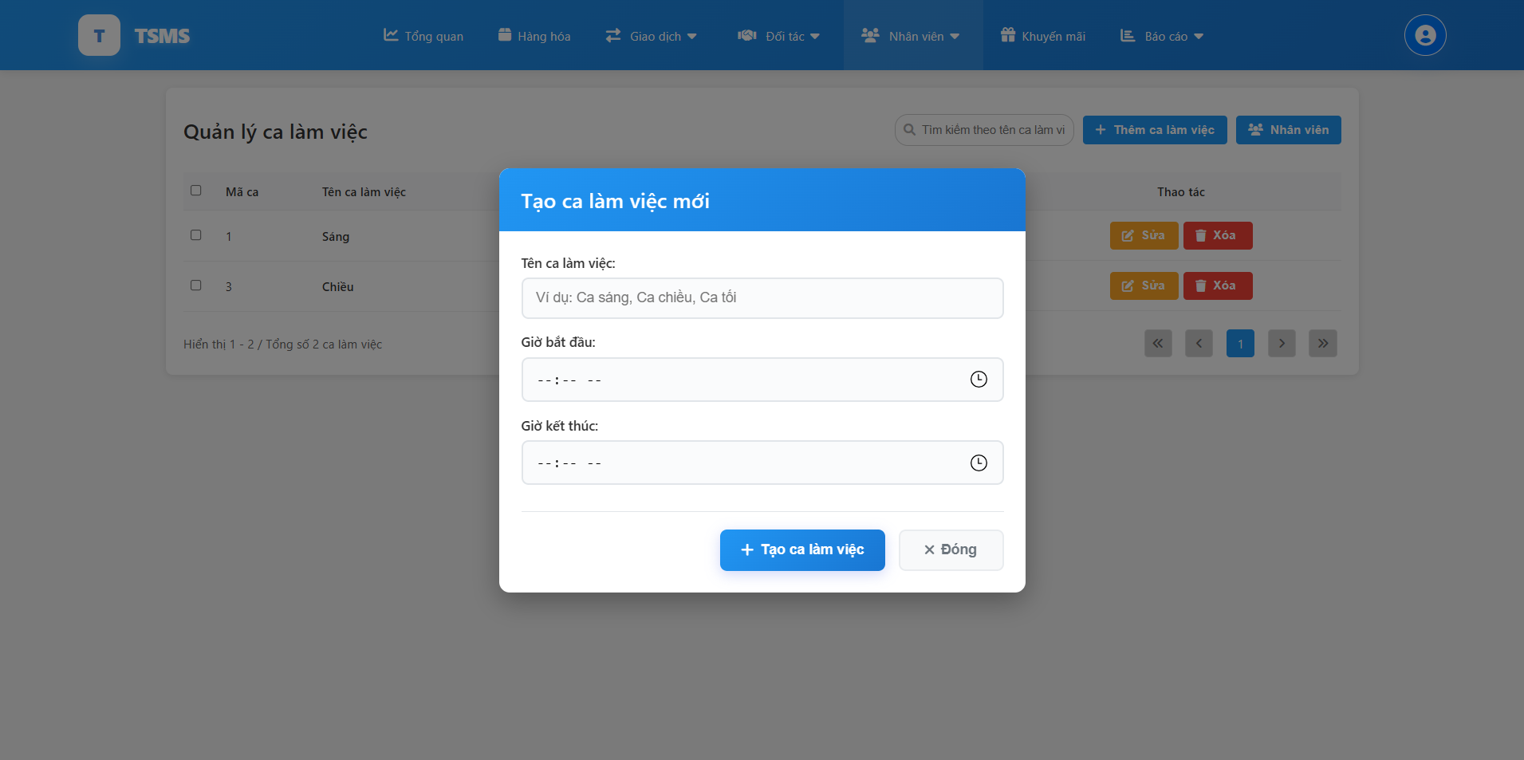

| **Field Name** | **Field Type** | **Description** |
| --- | --- | --- |
| Tên ca làm việc | Text Input | The name of the new work shift. |
| Giờ bắt đầu | Time Input | The starting time for the new work shift. |
| Giờ kết thúc | Time Input | The ending time for the new work shift. |
| Tạo ca làm việc | Button | Button to confirm and create the new work shift. |
| Đóng | Button | Button to close the pop-up without creating a new work shift. |

##### 

##### Database Access

##### 

| **Table** | **CRUD** | **Description** |
| --- | --- | --- |
| Staff | C | Used to store new work shift data. |

## 8. Promotion Management

### 8.1 View promotion list

This screen allows shop owners to view a comprehensive list of all promotions. It also provides summary statistics for different promotion states, filtering options by status and discount range, and a search bar to find specific promotions.

Related use cases:

* UC-25_View promotion list

##### UI Design

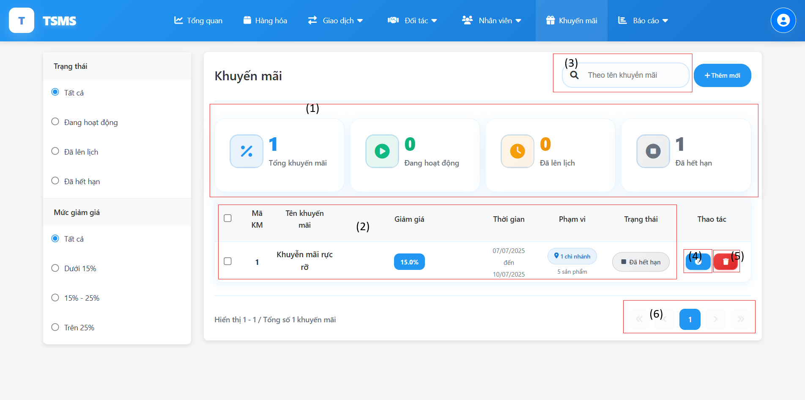

| **Field Name** | **Field Type** | **Description** |
| --- | --- | --- |
| Trạng thái | Radio | Allows filtering promotions by their status. |
| Mức giảm giá | Radio | Allows filtering promotions by their discount percentage range. |
| Thêm mới | Button | To create a new promotion. |
| (1) | Text | Overall information of all the promotions in the shop. |
| (2) | Text | Information about each of the promotions in the shop. |
| (3) | Text input | Text input field for searching promotion by name. |
| (4) | Button | View details of selected promotion. |
| (5) | Button | Delete the promotion. |
| (6) | Button | Navigation buttons for pagination. |

##### 

##### Database Access

##### 

| **Table** | **CRUD** | **Description** |
| --- | --- | --- |
| Promotions | R | Used to retrieve all promotions information. |
| PromotionBranches | R | Used to get how many branches that the promotion applied. |

### 8.2 Update promotion details

This screen allows shop owners to modify the detailed information of an existing promotion.

Related use cases:

* UC-26_Update promotion details

##### UI Design

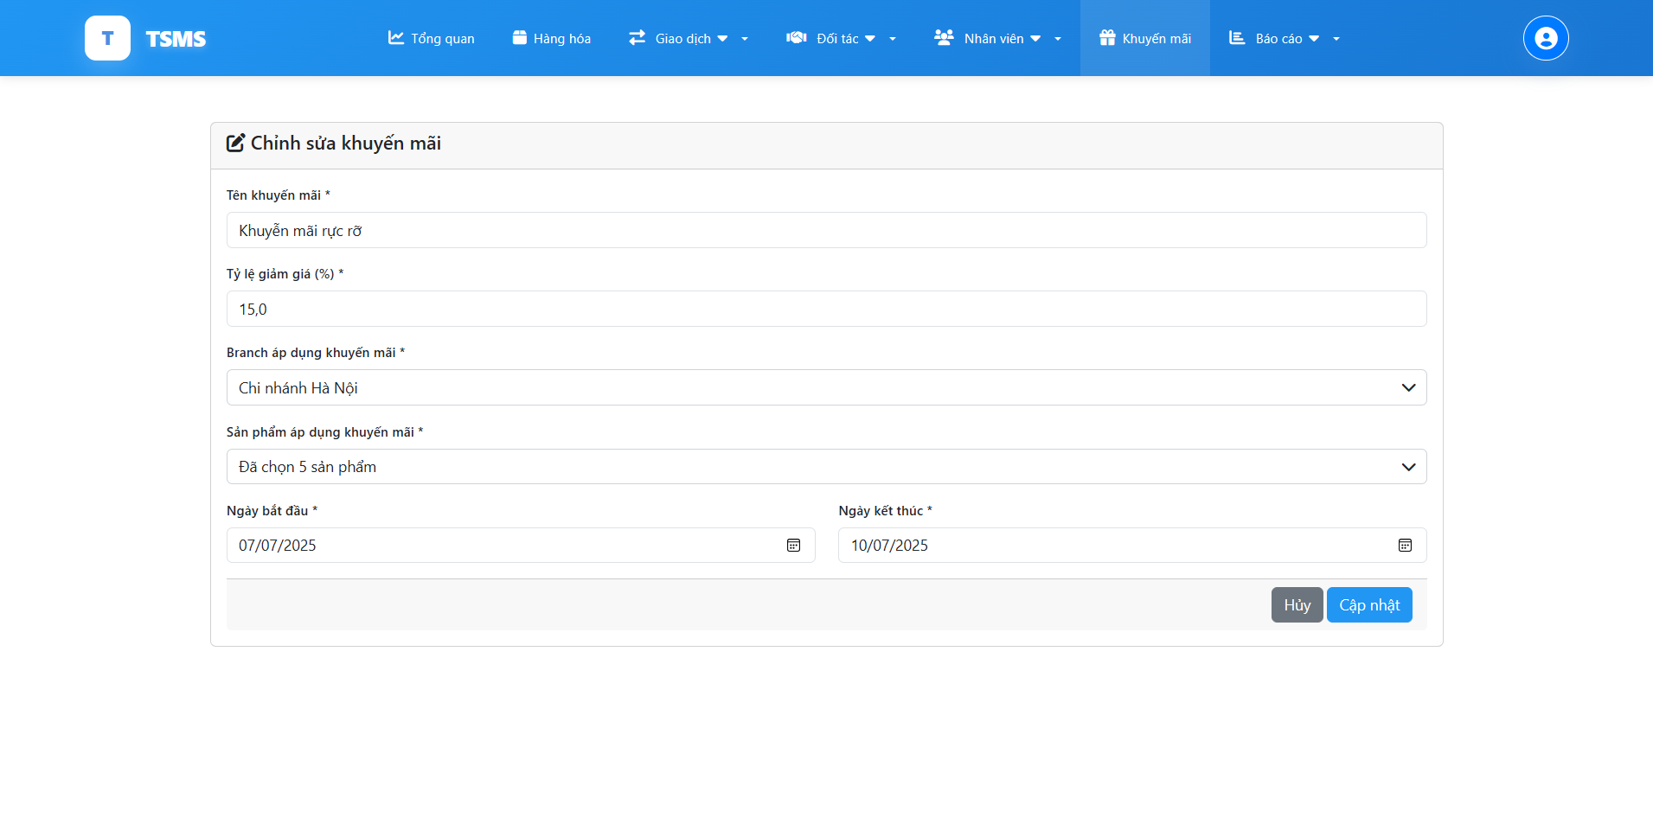

| **Field Name** | **Field Type** | **Description** |
| --- | --- | --- |
| Tên khuyến mãi | Text Input | Name or title of the promotion |
| Tỷ lệ giảm giá (%) | Number Input | Percentage of discount applied by the promotion |
| Branch áp dụng khuyến mãi | Dropdown | The branch(es) where the promotion is applicable |
| Sản phẩm áp dụng khuyến mãi | Dropdown | The specific products or a selection of products to which the promotion applies |
| Ngày bắt đầu | Date Picker | The start date of the promotion's validity |
| Ngày kết thúc | Date Picker | The end date of the promotion's validity |
| Hủy | Button | Button to cancel the edit and discard changes. |
| Cập nhật | Button | Button to save the updated promotion information. |

##### 

##### Database Access

##### 

| **Table** | **CRUD** | **Description** |
| --- | --- | --- |
| Promotions | U | Store the new promotion data changed. |
| Branches | R | Used to get branches that the promotion would be applied to. |
| Products | R | Used to get promotions that the promotion would be applied to. |
| PromotionBranches | U | Store branch(es) that changed promotion applied to. |
| PromotionProducts | U | Store product(s) that changed promotion applied to. |

### 8.3 Create a new promotion

This screen allows shop owners to create a new promotion, they can choose what branch and product that the promotion would be applied on.

Related use cases:

* UC-27_Create a new promotion

##### UI Design

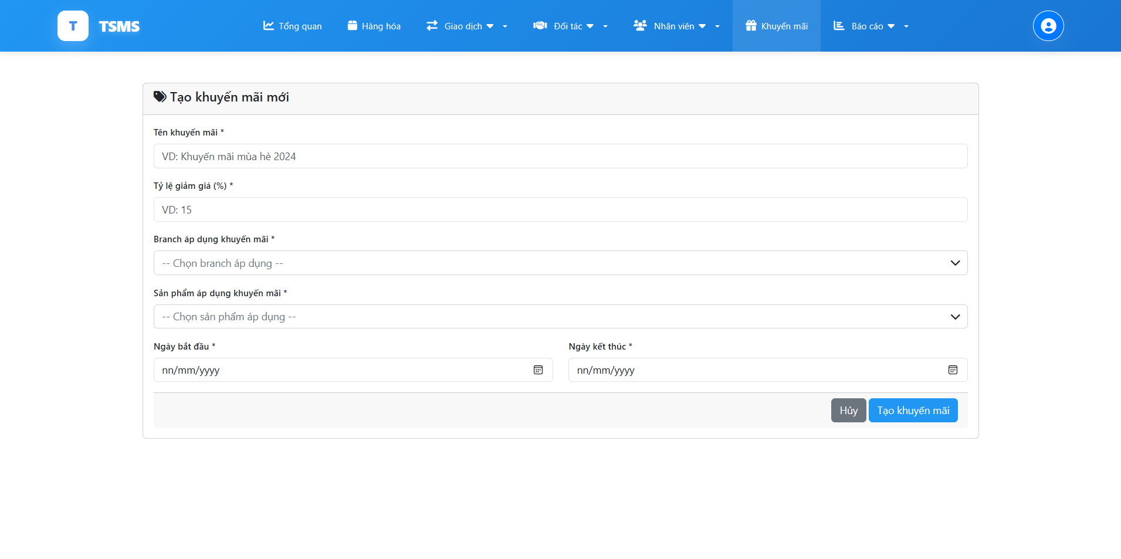

| **Field Name** | **Field Type** | **Description** |
| --- | --- | --- |
| Tên khuyến mãi | Text Input | To input name or title of the new promotion |
| Tỷ lệ giảm giá (%) | Number Input | Percentage of discount applied by the new promotion |
| Branch áp dụng khuyến mãi | Dropdown | To select the branch(es) where the new promotion is applicable |
| Sản phẩm áp dụng khuyến mãi | Dropdown | To select the specific products or a selection of new products to which the promotion applies |
| Ngày bắt đầu | Date Picker | To input start date of the new promotion's validity |
| Ngày kết thúc | Date Picker | To input the end date of the new promotion's validity |
| Hủy | Button | Button to cancel the edit and discard changes. |
| Cập nhật | Button | Button to save the updated promotion information. |

##### 

##### Database Access

##### 

| **Table** | **CRUD** | **Description** |
| --- | --- | --- |
| Promotions | C | Store the new promotion data created. |
| Branches | R | Used to get branches that the promotion would be applied to. |
| Products | R | Used to get promotions that the promotion would be applied to. |
| PromotionBranches | C | Store branch(es) that new promotion applied to. |
| PromotionProducts | C | Store product(s) that new promotion applied to. |

## 9. Shop/Branch Report

### 9.1 Revenue Report

This screen allows users to view revenue reports and exports by excel.

Related use cases:

* UC-28_View report

##### UI Design

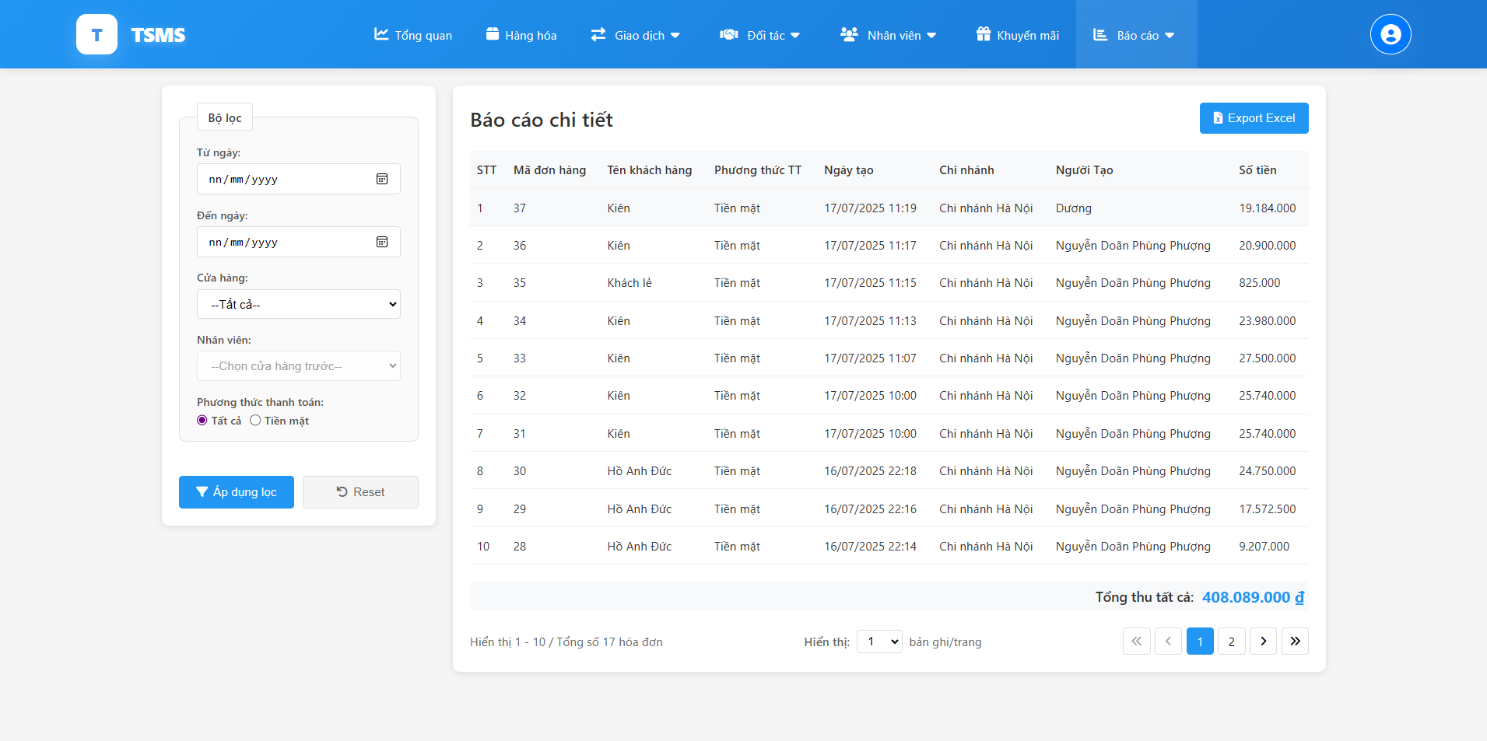

| **Field Name** | **Field Type** | **Description** |
| --- | --- | --- |
| fromDate | Date Input | Start date filter for report period |
| toDate | Date Input | End date filter for report period |
| branchId | Select | Branch/store selection filter |
| employeeId | Select | Employee selection filter (depends on selected branch) |
| paymentMethod | Radio Button | Payment method filter (Cash, Card, Bank Transfer, etc.) |
| page | Hidden Input | Current page number for pagination |
| recordsPerPage | Select | Number of records to display per page |
| reportType | Parameter | Type of report (income/outcome) |
| incomeList/outcomeList | List | List of cash flow records to display in table |
| totalIncomeAmount/totalOutcomeAmount | Display | Total amount summary (formatted currency) |
| currentPage | Display | Current page number for pagination display |
| totalPages | Display | Total number of pages |
| totalRecords | Display | Total number of records found |
| startRecord | Display | Starting record number on current page |
| endRecord | Display | Ending record number on current page |
| branchList | List | List of all branches for dropdown |
| employeeList | List | List of employees filtered by selected branch |
| paymentMethodList | List | List of available payment methods |
| fromDate | Date Input | Start date filter for report period |

##### 

##### Database Access

##### 

| **Table** | **CRUD** | **Description** |
| --- | --- | --- |
| CashFlows | R | Get income/outcome cash flow reports with pagination and filters, get all available payment methods for filter dropdown, get total count of cash flow records matching filters, get total amount sum for all matching records. |
| Branches | R | Get all branches for branch selection filter |
| Users | R | Get staff members by branch ID for employee filter |
| Orders | R | Get related order information for cash flow records |
| Customers | R | Get customer names for order-related cash flows |
| CashFlows | R | Export filtered data to Excel format |

### 9.2 Expense Report

This screen allows users to view expense report and export by excel

Related use cases:

* UC-28_View report

##### UI Design



| **Field Name** | **Field Type** | **Description** |
| --- | --- | --- |
| fromDate | Date Input | Start date filter for outcome report period |
| toDate | Date Input | End date filter for outcome report period |
| branchId | Select | Branch/store selection filter |
| employeeId | Select | Employee selection filter (depends on selected branch) |
| paymentMethod | Radio Button | Payment method filter for expense transactions |
| page | Hidden Input | Current page number for pagination |
| recordsPerPage | Select | Number of expense records to display per page |
| outcomeList | List | List of expense/outcome cash flow records to display |
| totalOutcomeAmount | Display | Total expense amount summary (formatted currency) |
| currentPage | Display | Current page number for pagination display |
| totalPages | Display | Total number of pages |
| totalRecords | Display | Total number of expense records found |
| startRecord | Display | Starting record number on current page |
| endRecord | Display | Ending record number on current page |
| branchList | List | List of all branches for dropdown selection |
| employeeList | List | List of employees filtered by selected branch |
| paymentMethodList | List | List of available payment methods for expenses |

##### 

##### Database Access

##### 

| **Table** | **CRUD** | **Description** |
| --- | --- | --- |
| CashFlows | R | Get outcome/expense cash flow reports with pagination and filters  Get all available payment methods for expense filter dropdown  Get total count of outcome cash flow records matching filters  Get total expense amount sum for all matching records |
| Branches | R | Get all branches for branch selection filter |
| Users | R | Get staff members by branch ID for employee filter (getStaffsByBranchIDForOutcome) |
| CashFlows | R | Export filtered expense data to Excel format |

## 10. Sell-in-store

### 10.1 Process of creating an order

This screen allows branch managers to create new sales orders (invoices) by selecting products from a list, adding them to the invoice, associating a customer (existing or new), applying discounts, and proceeding to the payment process. It also enables them to finalize the transaction by selecting payment methods, handling taxes, recording the amount paid by the customer, and calculating change.

Related use cases:

* UC-29_Create a new order

##### UI Design

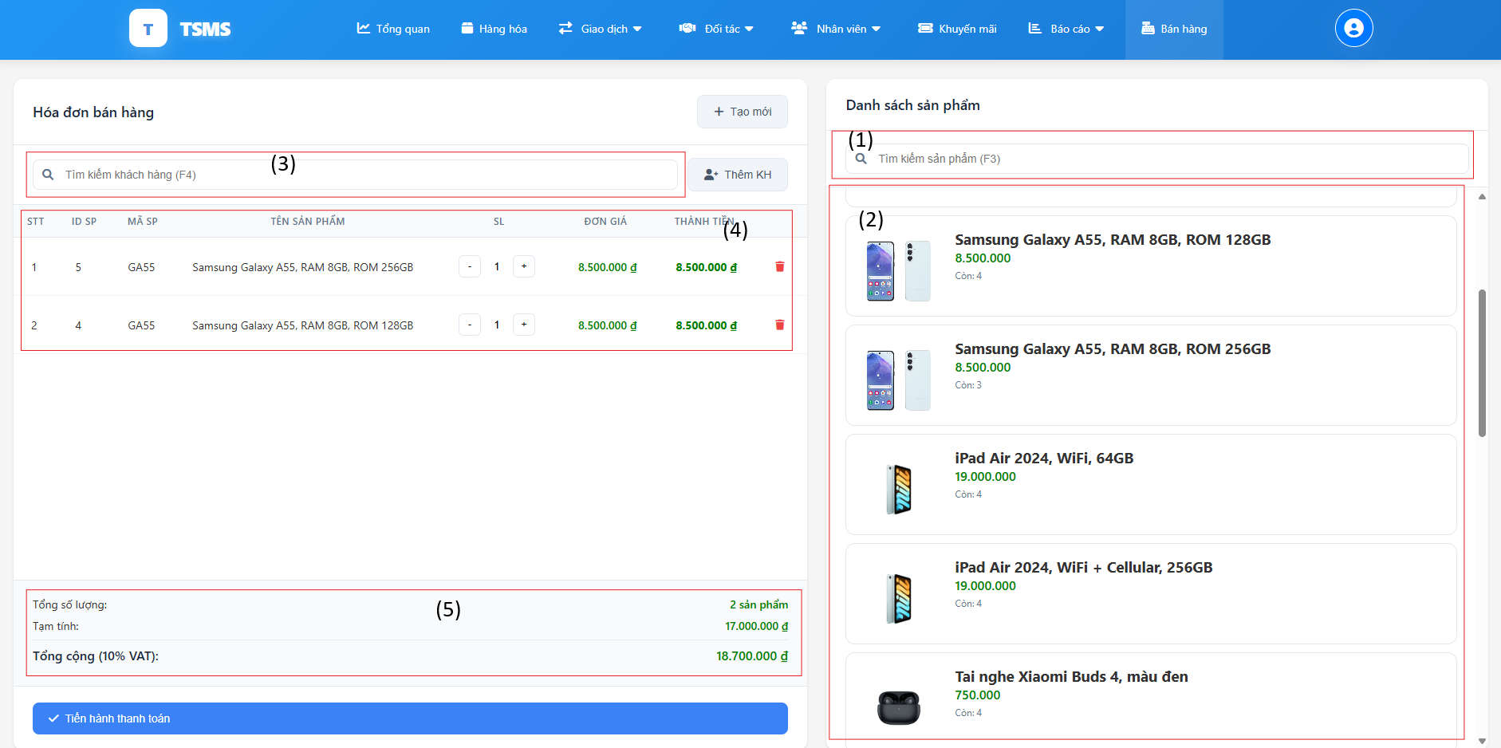

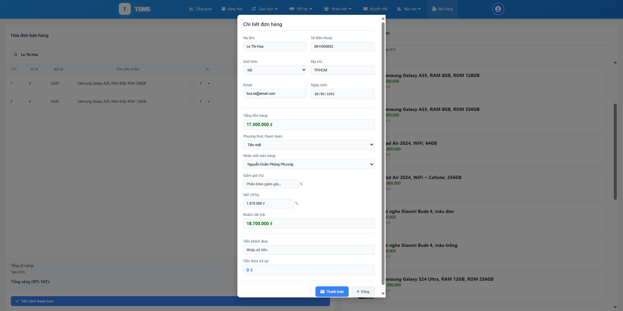

| **Field Name** | **Field Type** | **Description** |
| --- | --- | --- |
| *Order create screen* | | |
| (1) | Search Input | Search bar to find products from the "Danh sách sản phẩm" (Product List) by their name. |
| (2) | Product List (Display) | Section displaying available products that can be added to the invoice, typically showing product image, name, price, and stock count. |
| (3) | Search Input | Search bar to find customers by phone or name to associate with the invoice. |
| (4) | Text/ Button | Show the products selected in the order. Actions available for each product line item in the invoice, such as adjusting quantity or removing the product. |
| (5) | Text | Displays a summary of the current invoice, including total quantity of products, temporary total (subtotal), and total amount including VAT. |
| Tạo mới | Button | Button to create a new, blank invoice or clear the current one. |
| Thêm KH | Button | Button to add a new customer or select an existing one for the invoice. |
| Tiến hành thanh toán | Button | Button to proceed to the payment process for the current invoice. |
| *Order details screen* | | |
| Họ tên | Text Input | Name of the customer for the order. |
| Số điện thoại | Text Input | Phone number of the customer. |
| Giới tính | Dropdown | Gender of the customer. |
| Địa chỉ | Text Input | Address of the customer. |
| Email | Text Input | Email address of the customer. |
| Ngày sinh | Date Picker | Date of birth of the customer. |
| Tổng tiền hàng | Currency Display | Total price of all items in the order before discounts. |
| Phương thức thanh toán | Dropdown | Method of payment for the order. |
| Nhân viên bán hàng | Dropdown | The staff member who is handling the sale. |
| Giảm giá (%) | Number Input | Percentage discount applied to the order . |
| Tiền giảm giá | Currency Input | Monetary value of the discount applied. |
| VAT (%) | Number Input | Value Added Tax percentage applied. |
| Khách cần trả | Currency Display | The total amount the customer needs to pay after all calculations. |
| Tiền khách đưa | Currency Input | Amount of money received from the customer. |
| Tiền thừa trả lại | Currency Display | Change to be given back to the customer. |
| Thanh toán | Button | Button to finalize the payment and complete the order. |
| Đóng | Button | Button to close the pop-up without finalizing the payment. |

##### 

##### Database Access

##### 

| **Table** | **CRUD** | **Description** |
| --- | --- | --- |
| Products | R | Used to retrieve the list of products. |
| ProductDetail | R | Used to retrieve specific information about each product. |
| Customers | R | Used to retrieve customer lists. |
| Orders | C | Used to store general information about new orders. |
| OrderDetails | C | Used to store specific information about new orders. |
| CashFlows | C | Used to record cash inflow upon order completion. |
| Staff | R | Used to retrieve the list of staff members, thereby recording which sales staff member marketed the order. |
| Announcements | C | Used to generate new order notifications in the system. |
| Inventory | R | Used to retrieve the quantity of inventory in the branch's warehouse. |

### 10.2 Add a new customer

This screen allows branch managers to view a form for entering details to create a new customer record, including their full name, phone number, gender, address, email, and date of birth.

Related use cases:

* UC-30_Add a new customer

##### UI Design

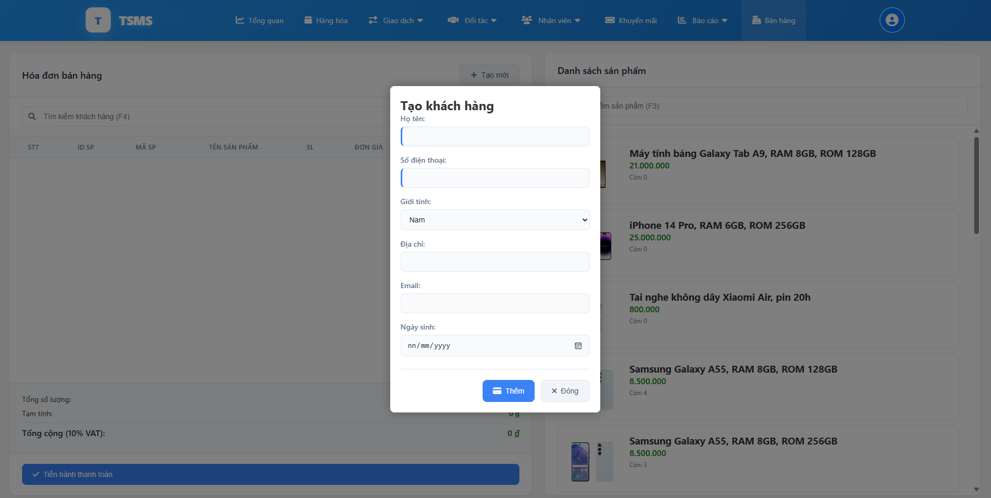

| **Field Name** | **Field Type** | **Description** |
| --- | --- | --- |
| Họ tên | Text Input | Full name of the new customer. |
| Số điện thoại | Text Input | Phone number of the new customer. |
| Giới tính | Dropdown | Gender of the new customer. |
| Địa chỉ | Text Input | Address of the new customer. |
| Email | Text Input | Email address of the new customer. |
| Ngày sinh | Date Picker | Date of birth of the new customer. |
| Thêm | Button | Button to add/create the new customer. |
| Đóng | Button | Button to close the pop-up without creating a new customer. |

##### 

##### Database Access

##### 

| **Table** | **CRUD** | **Description** |
| --- | --- | --- |
| Customers | C | Used to store new customers. |

## 11. Import/ Export Management

### 11.1. Tracking Import orders (Warehouse Manager)

This screen allows warehouse managers to view and manage import orders from suppliers. The interface displays a filtered list of stock movement requests showing order details including:

Related use cases:

● UC-31_

##### UI Design

### 

| **Field Name** | **Field Type** | **Description** |
| --- | --- | --- |
| fromDate | Date Input | Start date filter for import request period |
| toDate | Date Input | End date filter for import request period |
| status | Radio Button | Status filter (All, Completed, Pending, Processing, Cancelled) |
| page | Hidden Input | Current page number for pagination |
| recordsPerPage | Select | Number of import records to display per page (5, 10, 20, 50) |
| importRequests | List | List of stock movement requests for import operations |
| currentPage | Display | Current page number for pagination display |
| totalPages | Display | Total number of pages |
| totalItems | Display | Total number of import requests found |
| itemsPerPage | Display | Number of items displayed per page |
| startItem | Display | Starting item number on current page |
| endItem | Display | Ending item number on current page |
| warehouseId | Session | Current warehouse ID from session |

##### Database Access

| **Table** | **CRUD** | **Description** |
| --- | --- | --- |
| StockMovementsRequest | R | Get import requests with filters and pagination (getImportRequestsWithFilter)  Get total count of import requests matching filters (getImportRequestsCount)  Get response status for each import request |
| Suppliers | R | Get supplier information for import requests (fromSupplierName) |
| Users | R | Get creator information for import requests (createdByName) |
| StockMovementDetail | R | Get detailed items and amounts for import requests |
| ProductDetails | R | Get product information for import request items |
| Products | R | Get product names and details for import operations |

### 11.2 Tracking Export Order (Warehouse Manager)

### This screen allows warehouse managers to view and manage export orders to branches. The interface displays a filtered list of stock movement requests for outbound shipments including:

Related use cases:

● UC-32

**UI Design**  
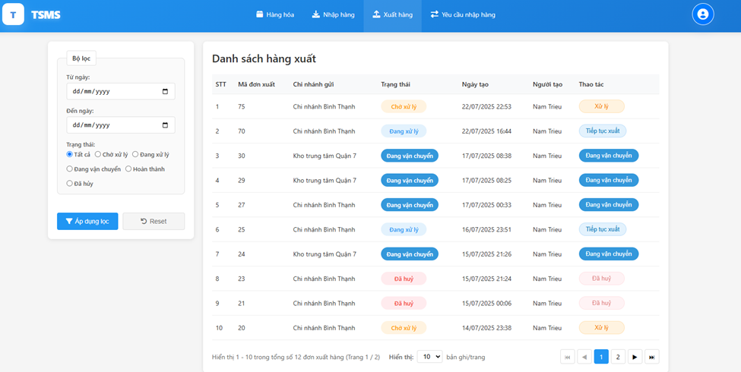

| **Field Name** | **Field Type** | **Description** |
| --- | --- | --- |
| fromDate | Date Input | Start date filter for export order period (Từ ngày) |
| toDate | Date Input | End date filter for export order period (Đến ngày) |
| status | Radio Button | Status filter (All, Pending, Processing, In Transit, Completed, Cancelled) |
| page | Hidden Input | Current page number for pagination |
| recordsPerPage | Select | Number of export records to display per page (10 shown) |
| exportRequests | List | List of export orders to branches |
| movementID | Display | Export order ID number (Mã đơn xuất) |
| branchName | Display | Destination branch name (Chi nhánh gửi) |
| responseStatus | Display | Order status with colored badges (Trạng thái) |
| createdAt | Display | Order creation date and time (Ngày tạo) |
| createdByName | Display | Creator name (Người tạo - showing Nam Triều) |
| currentPage | Display | Current page number (1) |
| totalPages | Display | Total number of pages (2) |
| totalItems | Display | Total number of export orders (12) |
| startItem | Display | Starting item number (1) |
| endItem | Display | Ending item number (10) |

##### Database Access

| **Table** | **CRUD** | **Description** |
| --- | --- | --- |
| StockMovementsRequest | R | Get export requests with filters and pagination  Get total count of export requests matching filters |
| Branches | R | Get destination branch information |
| Users | R | Get creator information for export requests |
| StockMovementResponses | R | Get response status for each export request |
| StockMovementDetail | R | Get detailed items for export shipments |
| ProductDetails | R | Get product information for export request items |
| Products | R | Get product names and details for export operations |

### 11.3.Tracking Import request ( Shop Owner)

This interface allows shop owners to track all stock movement activities across the entire system, with comprehensive filtering by date, movement type, and status:

Related use cases:

● UC-33_

##### UI Design

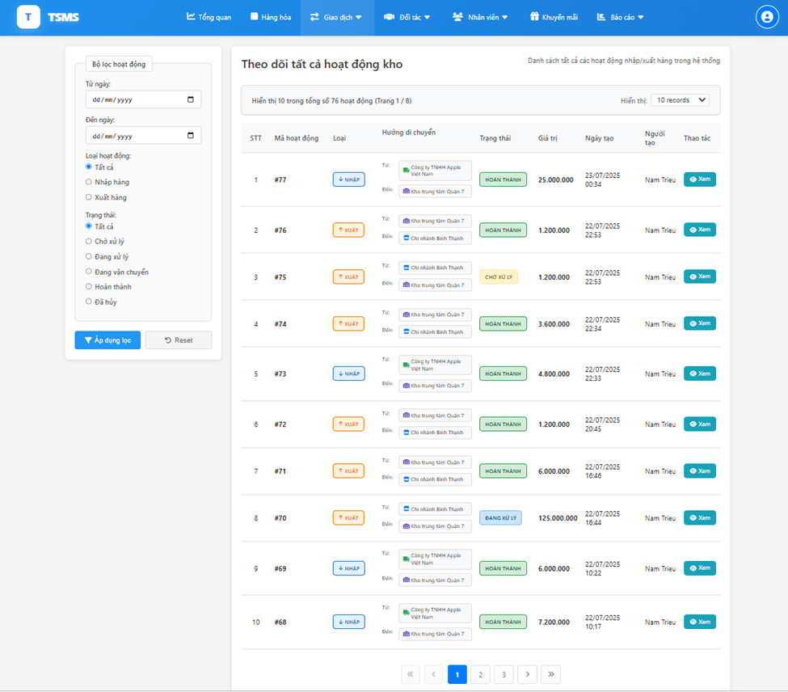

##### 

| **Field Name** | **Field Type** | **Description** |
| --- | --- | --- |
| fromDate | Date Input | Start date filter for tracking period (Từ ngày) |
| toDate | Date Input | End date filter for tracking period (Đến ngày) |
| movementType | Radio Button | Movement type filter |
| status | Radio Button | Status filter |
| page | Hidden Input | Current page number for pagination |
| pageSize | Select | Dynamic page size selector based on total records |
| allMovements | List | List of all stock movement activities |
| movementID | Display | Movement activity ID number |
| movementType | Display | Movement type badge with icons (Import/Export) |
| directionInfo | Display | Movement direction showing from/to locations |
| responseStatus | Display | Current status with colored badges |
| totalAmount | Display | Movement value in VND (Giá trị) |
| createdAt | Display | Creation date and time (Ngày tạo) |
| createdByName | Display | Creator name |
| currentPage | Display | Current page number |
| totalPages | Display | Total number of pages |
| totalRecords | Display | Total number of movements |
| currentPageSize | Display | Current items per page |
| pageSizeOptions | List | Dynamic page size options based on total records |

##### Database Access

| **Table** | **CRUD** | **Description** |
| --- | --- | --- |
| StockMovementsRequest | R | Get all stock movements with filters and pagination (getMovementsWithFilters)  Get total count of movements matching filters (getMovementsCount) |
| Suppliers | R | Get supplier information for import movements (Apple Vietnam, etc.) |
| Branches | R | Get branch information for movement origins and destinations |
| Warehouses | R | Get warehouse information for movement tracking |
| Users | R | Get creator information for movement activities |
| StockMovementResponses | R | Get response status for each movement |
| StockMovementDetail | R | Get detailed items and amounts for movement calculations |
| ProductDetails | R | Get product information for movement items |

### 

### 

### 11.4. Tracking import process (Branch Manager) This interface allows branch managers to track incoming orders/stock movements destined for their specific branch, with filtering by date range and status. Related use cases:

● UC-34_

##### UI Design

##### 

| **Field Name** | **Field Type** | **Description** |
| --- | --- | --- |
| fromDate | Date Input | Start date filter for incoming order period (Từ ngày) |
| toDate | Date Input | End date filter for incoming order period (Đến ngày) |
| status | Radio Button | Status filter (All, Pending, Processing, In Transit, Completed) |
| page | Hidden Input | Current page number for pagination |
| itemsPerPage | Select | Number of orders to display per page |
| exportRequests | List | List of incoming orders/stock movements to the branch |
| movementID | Display | Order movement ID number |
| fromBranchName | Display | Source location name (Nguồn) |
| responseStatus | Display | Order status with colored badges |
| formattedTotalAmount | Display | Order value in VND (Giá trị) |
| formattedDate | Display | Order creation date (Ngày tạo) |
| createdByName | Display | Order creator name (Người tạo) |
| currentPage | Display | Current page number |
| totalPages | Display | Total number of pages |
| totalItems | Display | Total number of incoming orders |
| startItem | Display | Starting item number on current page |
| endItem | Display | Ending item number on current page |
| branchId | Session | Current branch ID from session |
| successMessage | Session | Success notification message |
| errorMessage | Session | Error notification message |

##### 

##### 

##### Database Access

| **Table** | **CRUD** | **Description** |
| --- | --- | --- |
| StockMovementsRequest | R | Get export requests by destination branch with filters (getExportRequestsByToBranchWithFilter)  Get total count of export requests for branch (getExportRequestsByToBranchCount |
| Branches | R | Get source branch information for incoming orders |
| Warehouses | R | Get warehouse information for order sources |
| Users | R | Get creator information for order tracking |
| StockMovementResponses | R | Get response status for each incoming order |
| StockMovementDetail | R | Get detailed items and amounts for order calculations |
| ProductDetails | R | Get product information for incoming order items |
| Products | R | Get product names and details for order verification |
| StockMovementsRequest | R | Get export requests by destination branch with filters (getExportRequestsByToBranchWithFilter)  Get total count of export requests for branch (getExportRequestsByToBranchCount |
| Branches | R | Get source branch information for incoming orders |

##### 

### 11.5. Tracking export/import of warehouse (Shop Owner)

### The interface displays comprehensive order information including movement type badges, status indicators, and detailed product information with serial number tracking for inventory management.

Related use cases:

● UC-35_

**UI Design**  
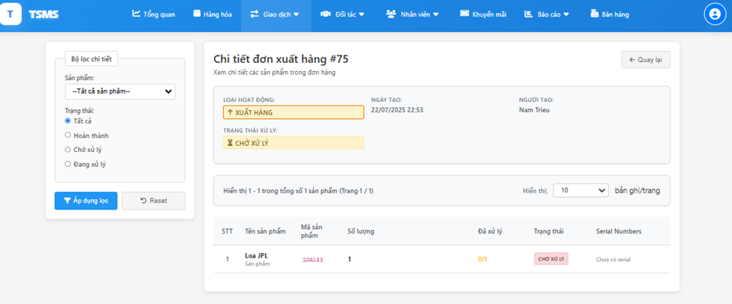

| **Field Name** | **Field Type** | **Description** |
| --- | --- | --- |
| id | Hidden Input | Movement ID parameter for the specific order being viewed |
| productFilter | Select | Product name filter dropdown for order details |
| status | Radio Button | Status filter (All, Completed, Pending, Processing) |
| page | Parameter | Current page number for pagination |
| itemsPerPage | Select | Number of order details to display per page (10, 25, 50) |
| orderInfo | Object | Complete order information including movement type, dates, creator |
| orderDetails | List | List of product details within the specific order |
| movementID | Display | Order movement ID number from URL parameter |
| movementType | Display | Type of movement (import/export) with icons |
| responseStatus | Display | Current order status with colored badges |
| formattedDate | Display | Order creation date formatted for display |
| createdByName | Display | Name of person who created the order |
| productName | Display | Name of each product in the order |
| productCode | Display | Product code for each item |
| quantity | Display | Required quantity for each product |
| scanned | Display | Number of items processed/scanned |
| serials | List | Serial numbers associated with each product |
| currentPage | Display | Current page number for pagination |
| totalPages | Display | Total number of pages |
| totalItems | Display | Total number of products in the order |
| startItem | Display | Starting item number on current page |
| endItem | Display | Ending item number on current page |
| productList | List | List of all products in order for filter dropdown |
| isReadOnly | Boolean | Flag indicating if order is in read-only mode |
| accessReason | String | Reason why user has access to view this order |

##### Database Access

| **Table** | **CRUD** | **Description** |
| --- | --- | --- |
| StockMovementsRequest | R | -Get export requests by destination branch with filters  -Get total count of export requests for branch |
| StockMovementDetail | R | -Get product details with filters and pagination -Debug serial data for troubleshooting -Get total count of order details for pagination  -Get product list for filter dropdown  -Get serial numbers for each product detail |
| ProductDetailSerialNumber | R | Get serial number information for order tracking |
| Products | R | Get product names and details for order display |
| ProductDetails | R | Get product codes and specifications |
| Users | R | Get creator information for order tracking |
| Branches | R | Get branch information for movement source/destination |

### 

### 11.6. Create order export (Branch Manager)

The interface displays current inventory levels, allows real-time quantity adjustments, and provides feedback through success/error messages. The two-panel layout shows the request form on the left and available products on the right for easy selection.

Related use cases:

● UC-36_

##### UI Design

| **Field Name** | **Field Type** | **Description** |
| --- | --- | --- |
| action | Hidden Input | Action parameter for different operations (add, updateQuantity, remove, reset, submitRequest) |
| supplierId | Select/Hidden | Supplier selection and identifier for cart management |
| productDetailID | Hidden Input | Product detail ID for cart operations |
| quantity | Number Input | Quantity input for each product in the request |
| keyword | Text Input | Search input for finding products by name or code |
| page | Hidden Input | Current page number for product pagination |
| toWarehouseID | Select/Hidden | Target warehouse selection dropdown |
| overallNote | Textarea | General notes/comments for the import request |
| cartItems | Session List | Cart items stored in session containing selected products |
| cartSupplierId | Session | Currently selected supplier ID stored in session |
| listSuppliers | List | List of all available suppliers |
| listWarehouse | List | List of all available warehouses |
| listProductDetails | List | Paginated list of products from selected supplier |
| selectedSupplierID | Display | Currently selected supplier ID for display |
| currentPage | Display | Current page number for pagination |
| totalPages | Display | Total number of pages for pagination |
| productCode | Display | Product code for each item in cart |
| productNameUnsigned | Display | Product name for display |
| formattedCostPrice | Display | Formatted unit price for each product |
| totalQuantity | Calculated | Total quantity of all items in the request |
| successMessage | Session | Success notification message |
| errorMessage | Session | Error notification message |
| justReset | Session Flag | Temporary flag to handle cart reset operations |

##### Database Access

| **Table** | **CRUD** | **Description** |
| --- | --- | --- |
| StockMovementsRequest | C | - Insert import movement request - Insert movement response with pending status |
| StockMovementDetail | C | Insert movement detail for each product |
| StockMovementResponses | C | Insert movement response with pending status |
| Suppliers | R | Get all suppliers for selection dropdown |
| Warehouses | R | Get all warehouses for destination selection |
| ProductDetails | R | - Get product detail by ID - Get paginated products by supplier  - Count products by supplier for pagination - Count search results by supplier |
| Announcements | C | Insert import request announcement |
| Products | R | Get product information for display purposes |

# III. System Design

## 1. Database Design

#### Link ERD: ([ERD.drawio - draw.io](https://app.diagrams.net/?splash=0#G1Har6juC8AM9KTqtYbIZ-zDQ94aDDa3Q9#%7B%22pageId%22%3A%22gTkMQU1sMg5poryigq3a%22%7D))

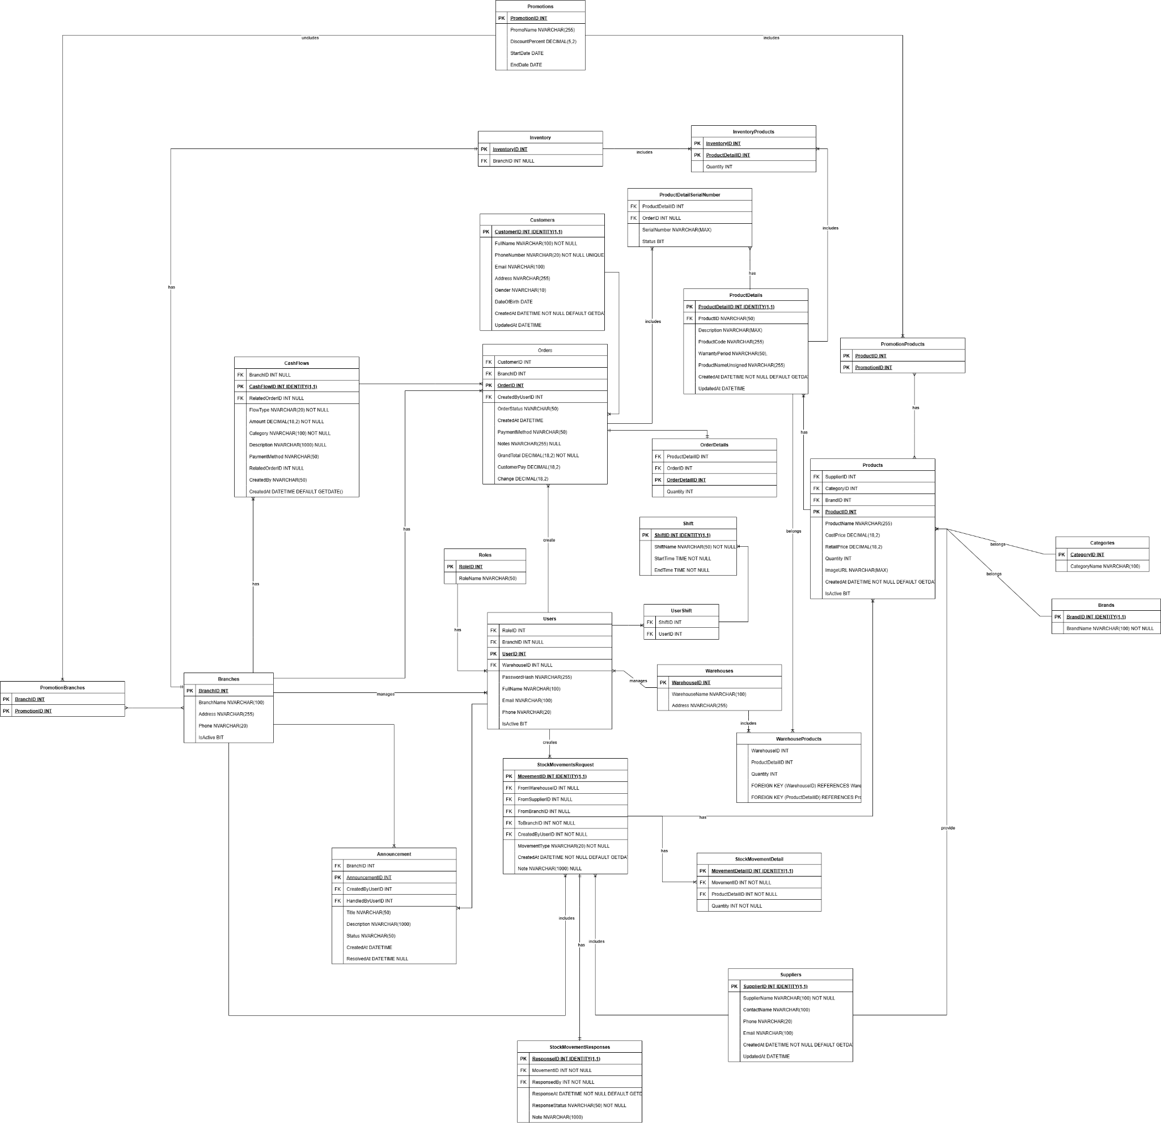

Store database scheme

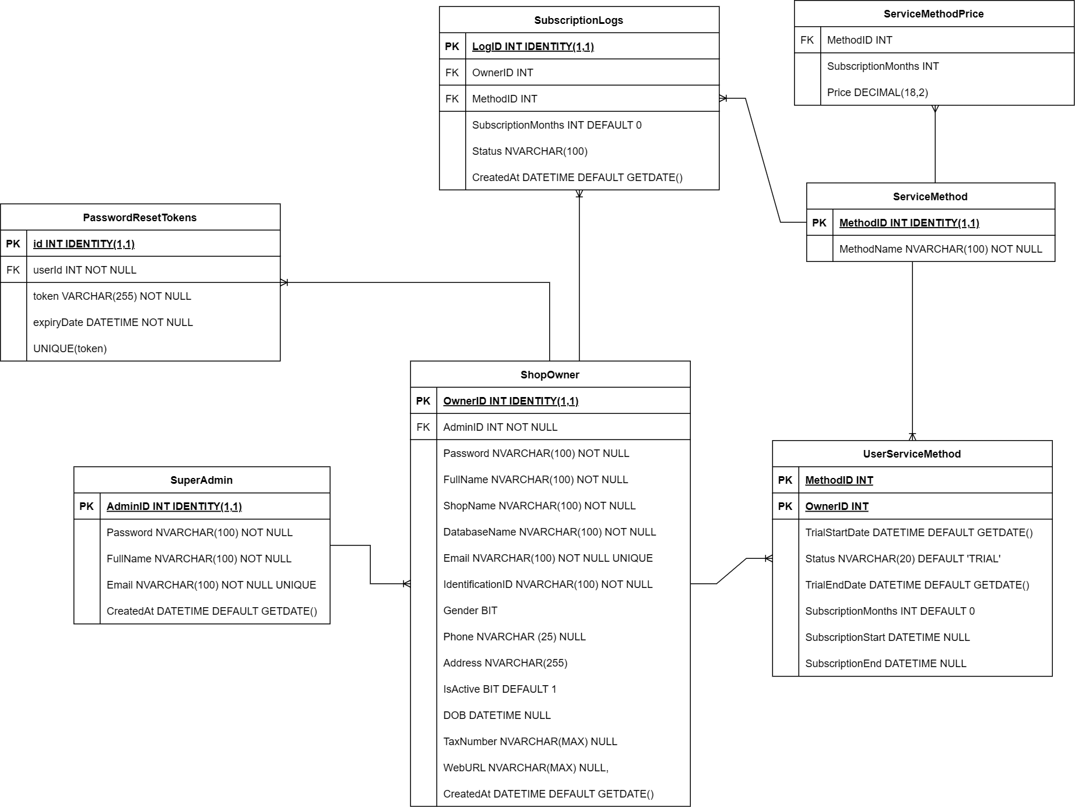

SuperAdmin database scheme

## 2. Table Descriptions

#### 2.1. Table Descriptions Of Store Database Scheme

| **No** | **Table** | **Description** |
| --- | --- | --- |
| 01 | Roles | Stores user roles such as Branch Manager, Sale, and Warehouse Manager.  **PK:** RoleID |
| 02 | Branches | Stores information of company branches including name, address, and phone.  **PK:** BranchID |
| 03 | Warehouses | Contains warehouse locations and names.  **PK:** WarehouseID |
| 04 | Users | Stores user accounts and assignments to branches or warehouses.  **PK:** UserID  **FKs:** RoleID → Roles, BranchID → Branches, WarehouseID → Warehouses |
| 05 | Categories | Product categories (e.g., Phones, Laptops).  **PK:** CategoryID |
| 06 | Suppliers | Information about suppliers providing the products.  **PK:** SupplierID |
| 07 | Brands | List of product brands.  **PK:** BrandID |
| 08 | Products | Core product data: name, brand, category, supplier, prices.  **PK:** ProductID  **FKs:** BrandID → Brands, CategoryID → Categories, SupplierID → Suppliers |
| 09 | ProductDetails | Detailed version of products including product code, warranty, etc.  **PK:** ProductDetailID  **FK:** ProductID → Products |
| 10 | WarehouseProducts | Tracks the quantity of each product detail in each warehouse.  **PK:** (WarehouseID, ProductDetailID)  **FKs:** WarehouseID → Warehouses, ProductDetailID → ProductDetails |
| 11 | Inventory | Each branch has one inventory record.  **PK:** InventoryID  **FK:** BranchID → Branches |
| 12 | InventoryProducts | Tracks the quantity of each product in detail in branch inventories.  **PK:** (InventoryID, ProductDetailID)  **FKs:** InventoryID → Inventory, ProductDetailID → ProductDetails |
| 13 | StockMovementsRequest | Stock movement requests between supplier/warehouse/branches.  **PK:** MovementID  **FKs:** FromSupplierID → Suppliers, FromBranchID/ToBranchID → Branches, FromWarehouseID/ToWarehouseID → Warehouses, CreatedBy → Users |
| 14 | StockMovementResponses | Logs responses to stock movement requests.  **PK:** ResponseID  **FKs:** MovementID → StockMovementsRequest, ResponsedBy → Users |
| 15 | StockMovementDetail | List of items included in a stock movement.  **PK:** MovementDetailID  **FKs:** MovementID → StockMovementsRequest, ProductDetailID → ProductDetails |
| 16 | Customers | Stores customer information like name, phone, address, etc.  **PK:** CustomerID |
| 17 | Orders | Sales orders created by employees for customers.  **PK:** OrderID  **FKs:** BranchID → Branches, CreatedBy → Users, CustomerID → Customers |
| 18 | OrderDetails | Details of products included in each order.  **PK:** OrderDetailID  **FKs:** OrderID → Orders, ProductDetailID → ProductDetails |
| 19 | ProductDetailSerialNumber | Tracks serial numbers of individual product items.  **PK:** (assumed composite)  **FKs:** ProductDetailID → ProductDetails, OrderID → Orders, BranchID → Branches, WarehouseID → Warehouses |
| 20 | Promotions | Promotional programs with discounts and duration.  **PK:** PromotionID |
| 21 | PromotionBranches | Links promotions to participating branches.  **PK:** (PromotionID, BranchID)  **FKs:** PromotionID → Promotions, BranchID → Branches |
| 22 | PromotionProducts | Links promotions to applicable product details.  **PK:** (PromotionID, ProductDetailID)  **FKs:** PromotionID → Promotions, ProductDetailID → ProductDetails |
| 23 | Announcements | System announcements created by users, often for issue tracking.  **PK:** AnnouncementID  **FKs:** CreatedBy → Users, HandledBy → Users, BranchID → Branches |
| 24 | CashFlows | Logs financial cash in/out for orders or manual operations.  **PK:** CashFlowID  **FKs:** RelatedOrderID → Orders, BranchID → Branches |
| 25 | Shift | Shifts for staffs **PK**: ShiftID |
| 26 | UserShift | Present user in which shift  **FKs:** ShiftID -> Shift, UserID -> Users |

#### 

#### 2.2. Table Descriptions Of SuperAdmin Database Scheme

| **No** | **Table** | **Description** |
| --- | --- | --- |
| 01 | SuperAdmin | Stores system super admin accounts.  **PK:** AdminID |
| 02 | ShopOwner | Represents shop owners, each linked to a SuperAdmin and their own database.  **PK:** OwnerID  **FK:** AdminID → SuperAdmin |
| 03 | ServiceMethod | Lists available service plans (e.g., Quản Lý Chuỗi Cửa Hàng, Quản lý nhân sự, Quản lý chuỗi Khách sạn,...).  **PK:** MethodID |
| 04 | UserServiceMethod | Tracks service method usage per ShopOwner with trial and subscription info.  **PK:** (OwnerID, MethodID)  **FKs:** OwnerID → ShopOwner, MethodID → ServiceMethod |
| 05 | PasswordResetTokens | Stores password reset tokens linked to ShopOwners for account recovery.  **PK:** id  **FK:** userId → ShopOwner  **Unique:** token |
| 06 | ServiceMethodPrice | Price of each method’s subscription  **FK:** MethodID |
| 07 | SubscriptionLogs | Logs of subscription requests  **PK:** id  FK:OwnerID -> ShopOwner, MethodID -> ServiceMethod |

#### 

## 2. Code Packages

### 2.1 Package Diagram

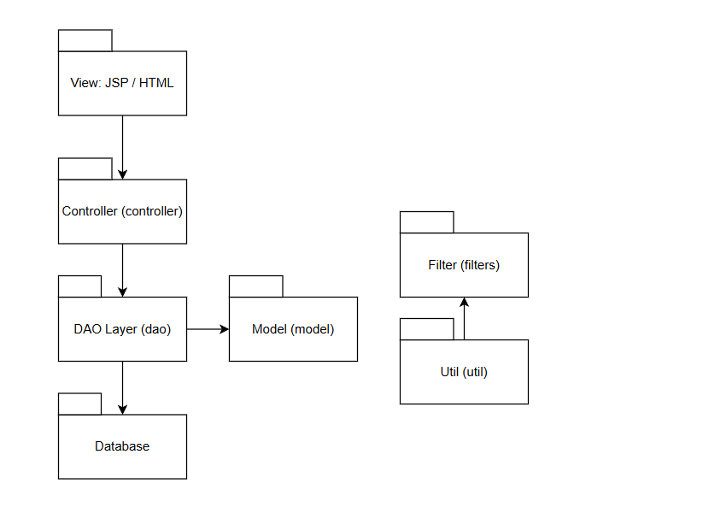

### 2.2 Package Descriptions

| **No** | **Package** | **Description** |
| --- | --- | --- |
| *01* | *View: JSP / HTML* | *This is the presentation layer, which includes .jsp pages (e.g. customer details, dashboard), static files like index.html, CSS and JavaScript. It captures user input and displays dynamic data returned from the controller* |
| *02* | *Controller* | *Servlets located in the controller package. They receive HTTP requests, handle application logic, invoke DAO classes for data operations, and forward results to the appropriate JSPs (View layer).* |
| *03* | *DAO (Data Access Object)* | *DAO (Data Access Object) DAO classes in the dao package interact with the database using JDBC. They perform CRUD operations and return data as model objects (POJOs).* |
| *04* | *Model* | *Model JavaBeans/POJOs that represent database entities. These classes contain private fields, constructors, and getter/setter methods.* |
| *05* | *Database* | *Database A relational database that stores the system's business data in tables such as Customers, Orders, Products, Users.* |
| *06* | *Filter* | *Filter Classes in the filters package intercept requests before they reach the controller. Used for authentication, authorization, session management.* |
| *07* | *Util* | *Util Utility classes used throughout the application. Provide shared helper functions like database connection management, date formatting.* |

# IV. Appendix

## 1. Assumptions & Dependencies

### 1.1. Assumptions

* **AS-1:** Each Shop Owner will manage their own branches, staff, inventory, and sales independently using the system.
* **AS-2:** All users (Super Admin, Shop Owner, Branch Manager, Sale, Warehouse Manager) internet connections to use the system effectively.  
  **AS-3:** All business rules and workflows provided by the stakeholders reflect real-world operations and will not change significantly during development.
* **AS-4:** All system users will receive adequate training or onboarding to operate the system efficiently.
* **AS-5:** Each Shop Owner is responsible for providing accurate business and operational data (e.g., staff info, product info, inventory levels) during initial setup.

### 1.2. Dependencies

* **DE-1:** The system depends on SQL Server for database storage and Java (Servlet/JSP) for backend operations.
* **DE-2:** Integration with third-party email/SMS gateways is required to send notifications (e.g., order confirmations, alerts).
* **DE-3:** The system depends on external payment gateway services for subscription payment processing.
* **DE-4:** Scheduled tasks require a stable server environment or cloud hosting infrastructure.

## 2. Limitations & Exclusions

#### 2.1. Limitations

* Only supports web platforms: The system only runs on a web browser, there is no separate application for iOS or Android.
* Only supports Vietnamese: The system interface and content currently only support Vietnamese language.
* No offline mode: Users must have an Internet connection to use the system. No support for offline data entry or synchronization.
* No advanced analysis: The system only supports basic reports (revenue, expenses), no prediction, machine learning or artificial intelligence (AI) features.
* No hardware integration: No support for integration with receipt printers, barcode scanners, cash drawers, etc.
* No multi-currency support: All transactions and financial reports are in VND (Vietnamese Dong).

#### 2.2. Exclusions

* End-customer application: The system does not include a website or application for customers to use to make purchases or track orders.
* E-commerce platform integration: Does not integrate with platforms such as Shopee, Lazada, Tiki, TikTok Shop, etc.
* Accounting software integration: The system does not connect with third-party accounting software such as MISA, QuickBooks, etc.
* Real-time chat feature: No internal chat or live chat with customers.
* Multi-language support: No language conversion mechanism or translation into English, Chinese, Japanese, etc.
* Advanced CRM or marketing automation integration: Does not include email marketing, campaign management or customer care automation functions.

## 3. Business Rules

| **ID** | **Category** | **Rule Definition** |
| --- | --- | --- |
| BR-01 | Constraints | Sales hours are from 8:00 AM to 9:00 PM. Orders cannot be created outside this time range. |
| BR-02 | Constraints | Staff can only create or process orders within the branch they are assigned to. |
| BR-03 | Facts | Each order must be linked to only one branch and one unique customer. |
| BR-04 | Facts | Each order must be paid using only one payment method. |
| BR-05 | Constraints | Each product code must be unique across the entire store and cannot be duplicated. |
| BR-06 | Computations | Order total = Subtotal – Discount + VAT. VAT is calculated after applying discounts. |
| BR-07 | Constraints | A staff member can only be assigned to one shift per day at one branch. |
| BR-08 | Constraints | Products with insufficient stock cannot be added to orders or stock transfer requests. |
| BR-09 | Constraints | Promotions can only be applied if the order meets all conditions regarding products and promotion time. |
| BR-10 | Constraints | Promotions cannot be applied if the product already has a fixed discounted price. |
| BR-11 | Constraints | Locked staff accounts cannot log in or perform any system operations. |
| BR-12 | Computations | Daily revenue = Total completed orders – refunds – promotion costs. |
| BR-13 | Facts | A Shop Owner can have multiple branches, but each branch belongs to only one Shop Owner. |
| BR-14 | Constraints | Unpaid orders will be automatically cancelled after 30 minutes if not completed. |
| BR-15 | Constraints | A work shift cannot overlap with existing shifts at the same branch. |

## 

## 